|  |  |
| --- | --- |
| \\VFILERDPI\DPI-Home\OBRIENR2\My Documents\Downloads\PP logo.jpg |  |
| **COUNCIL ASSESSMENT REPORT**  NORTHERN REGIONAL PLANNING PANEL | |

|  |  |
| --- | --- |
| PANEL REFERENCE & DA NUMBER | PPSNTH-208 – DA23/0113 |
| PROPOSAL | Waste or resource transfer station (WRTS) upgrade |
| ADDRESS | Lot 1 DP 1185359  16 Naru Street Chinderah 2487 |
| APPLICANT | Michael Mitchell || A1 Skips |
| OWNER | Michael & Joanne Mitchell |
| DA LODGEMENT DATE | 8 March 2023 |
| APPLICATION TYPE | Development Application (Designated and Integrated) |
| REGIONALLY SIGNIFICANT CRITERIA | Section 2.19(1) and Section 7(1)(c) of Schedule 6 of State Environmental Planning Policy (Planning Systems) 2021 declares the proposal regionally significant development as waste management facilities or works that meet the requirements for designated development under the Environmental Planning and Assessment Regulation 2021, Schedule 3, Section 45.  The proposed development is designated development pursuant to Clauses 45(4) (a), (b), (e) and (f) of Schedule 3 to the EP&A Regulations 2021. As such, the Northern Regional Planning Panel is the determining authority. |
| CIV | $26,776 (excluding GST) |
| CLAUSE 4.6 REQUESTS | No variations to development standards requested |
| KEY SEPP/LEP | * *State Environmental Planning Policy (Planning Systems) 2021;* * *State Environmental Planning Policy (Resilience and Hazards) 2021;* * *State Environmental Planning Policy (Transport and Infrastructure) 2021; and* * *Tweed Local Environmental Plan 2014.* |
| TOTAL & UNIQUE SUBMISSIONS KEY ISSUES IN SUBMISSIONS | One submission |
| DOCUMENTS SUBMITTED FOR CONSIDERATION | Environmental Noise Impact Report  Addendum to Environmental Noise Impact Assessment Report  Air Quality and Odour Impact Assessment  Desktop Biodiversity Impact Assessment Report  Capital Investment Value Estimate  Environmental Impact Statement  Fire Compliance Assessment  Response to Submissions Report  Community and Stakeholder Engagement Plan  Pollution Incident Response Management Plan  Visual Impact Assessment Report  Soil and Water Impact Assessment  Revised Traffic Impact Assessment  Waste Management Plan  Planning Secretary’s Environmental Assessment Requirements (SEAR) 1695  Amended Waste Management Plan  Response to Submissions #2 Letter  Response to Submissions #3 Letter |
| SPECIAL INFRASTRUCTURE CONTRIBUTIONS (S7.24) | Not applicable. |
| RECOMMENDATION | Approval |
| DRAFT CONDITIONS TO APPLICANT | YES |
| SCHEDULED MEETING DATE | 23 October 2023 |
| PREPARED BY | Kai Blackmore, Town Planner, Development Assessment Unit. |
| DATE OF REPORT | 9 October 2023 |

**EXECUTIVE SUMMARY**

Council is in receipt of a development application seeking consent for upgrade works to an existing approved Waste or Resource Transfer Station (WRTS) located at 16 Naru Street, Chinderah.

The upgrade works include the following:

* Increase the current capacity of the facility from 6,000 tonnes per annum (tpa) (as approved under Development Consent No. DA16/0647 (as amended)) to 15,000tpa;
* Increase in operational hours; and
* Minor infrastructure upgrade works to ensure compliance with WRTS best practice requirements.

Operational hours

Current (as approved under Development Consent No. DA16/0647 (as amended)):

* 7:00am to 6:00pm Mondays to Friday;
* 7:30am to 5:30pm Saturday; and
* No work to be carried out on Sundays or Public Holidays.

Proposed:

* 6:30am to 6:00pm Monday to Saturday; and
* No work to be carried out on Sundays or Public Holidays.

It is stated within the Environmental Impact Statement that vehicle movements between 6:30am and 7:00am will be limited to passenger vehicles and trucks up to 16 tonnes. No waste receival, sorting or noise generating plant or equipment will be operated until 7:00am. 2 movements for trucks up to 16 tonnes are conditioned between the hours of 6:30am and 7:00am.

Minor infrastructure upgrade works

* Marking the tip and spread area and the residual waste storage area using hard wearing paint onto the floor of the WRTS;
* Covering outdoor concrete and timber storage areas when not in use to minimise wind erosion of material stockpiles and washing of stockpiles during a rainfall event;
* Additional fire protection measures, including installation of:
  + Fire hose reel;
  + Smoke or heat/temperature detection system;
  + Automatic occupant warning system;
  + Manual alarm points;
  + Safety signage; and
  + Increase height of outdoor storage bays by 1m; and
* A grated trench drain to be provided along the front of the concrete and storage bay, including a below-ground impervious concrete sump with a minimum volume not less than 500 litres to meet EPA requirements.

The key development data is provided in **Table 1** below.

**Table 1: Key Development Data**

|  |  |
| --- | --- |
| Control | Proposal |
| Site area | 5042m2 |
| GFA | 480m2 (No proposed changes) |
| Clause 4.6 Requests | No |
| Max Building Height | 10m (No proposed changes) |
| Landscaped area | No changes |
| Car Parking spaces | 16 for the WRTS (No changes)  26 for the entire site (No changes) |
| Setbacks | No proposed changes |
| Staff Numbers | Increase in staff numbers from 11 to 15 |

The WRTS (known as “A1 Skips”) will continue to process inert, non-putrescible materials from building yard and construction sites such as concrete, bricks, metal and timber from the Tweed, Gold Coast and the greater Northern Rivers region. Waste will continue to be transported to the facility in skip bins which will be unloaded and sorted and processed. During this process any recyclable materials will continue to be sorted and sold for reuse where possible, whilst non recyclables will continue to be transported to offsite landfill locations for appropriate disposal. Consistent with Development Consent No. DA16/0647 (as amended) the facility will **not** receive any asbestos, liquids, chemicals, oils, fuels, perishable waste or industry waste.

No changes are proposed to the 3 existing general industrial tenancies on the site.

The upgrades to the WRTS are categorised as Designated Development in accordance with Clause 45 of Schedule 3 to the *Environmental Planning & Assessment (EP&A) Regulation 2021*, as the site is identified as being located on a floodplain (inundated as a result of the 1 in 100 year flood event) and being within 500 metres of a residential zone or 250 metres of a dwelling not associated with the development.

Section 2.19(1) and Section 7(1)(c) of Schedule 6 of *State Environmental Planning Policy (Planning Systems) 2021* declares the proposal regionally significant development as waste management facilities or works that meet the requirements for designated development under the [*Environmental Planning and Assessment Regulation 2021*](https://legislation.nsw.gov.au/view/html/inforce/current/sl-2021-0759), Schedule 3, Section 45. As such, the Northern Regional Planning Panel is the determining authority.

As above, the proponent seeks to process up to 15,000 tonnes of material per annum. Under the *Protection of the Environment Operations Act 1997* any development which triggers the Integrated Development provisions under the *Protection of the Environment Operations (PoEO) Act 1997* requires an Environmental Protection Licence from the NSW Environmental Protection Authority (EPA). Consistent with Section 42 of Schedule 1 of the PoEO Act 1997 any waste storage premises receiving more than 6,000 tonnes per year from off site is considered to be a scheduled activity and requires an Environmental Protection Licence from the EPA.

The application has been forwarded to relevant public authorities with a summary of their comments provided below.

|  |  |
| --- | --- |
| **Agency** | **Response** |
| Environmental Protection Authority (EPA) | General Terms of Approval issued. |
| Transport for New South Wales (TfNSW) | TfNSW raised no objection to the proposed development. No conditions provided. |
| Essential Energy | Essential Energy raised no objections subject to comments provided which are to be conditioned accordingly. |

Being Designated Development, the proponent was required to prepare an Environmental Impact Statement in accordance with the requirements of the Secretary’s Environmental Assessment Requirements (SEARs). The development is considered to have satisfactorily addressed the SEARs as demonstrated further in this report.

The proposal was advertised and notified in accordance with the Council’s *Community Participation Plan 2019 – 2024* with a submission period from Wednesday 26 April 2023 to Wednesday 24 May 2023. One unique submission in favour of the proposal, was received.

The following Units within Council have assessed the proposed development:

* Development Assessment Unit – No objections, subject to recommended conditions of consent.
* Building Services Unit – No objections, subject to recommended conditions of consent.
* Roads and Stormwater Unit – No objections, no recommended conditions of consent.
* Traffic Engineer – No objections, subject to recommended conditions of consent.
* Water and Wastewater Unit – No objections, no recommended conditions of consent.
* Environmental Health Unit – No objections, subject to recommended conditions of consent.

Council’s Environmental Health Officer has recommended a number of non-standard use conditions aimed at addressing any concerns with respect to the upgrade.

There are a number of planning legislation requirements that the consent authority must consider. A detailed assessment of the relevant clauses is noted within the report. A summary is noted below:

* **Clause 3.12 of Chapter 3 Hazardous and offensive development of State Environmental Planning Policy (Resilience and Hazards) 2021**. Council is satisfied that the proposal is not a hazardous industry and appropriate management strategies will be imposed to manage any offensive impacts associated with the proposal;
* **Clause 4.6 of Chapter 4 Remediation of land of State Environmental Planning Policy (Resilience and Hazards) 2021**. The proponent’s assessment of the subject site concluded that the land is not contaminated as assessed under Development Consent No. DA16/0647 and is suitable for the proposed development. Council officers are satisfied that the proposed development meets the provisions of Clause 4.6;
* **Clause 2.48 of Chapter 2 of State Environmental Planning Policy (Transport and Infrastructure) 2021 – Determination of Development Application – other development.** Clause 2.48 (2) states that before determining a development application (or an application for modification of a consent) for development to which this clause applies, the consent authority must:

(a)  give written notice to the electricity supply authority for the area in which the development is to be carried out, inviting comments about potential safety risks, and

(b)  take into consideration any response to the notice that is received within 21 days after the notice is given.

Essential Energy have made a submission and appropriate conditions are recommended.

* **Clause 2.122 of State Environmental Planning Policy (Transport and Infrastructure) 2021 – *Traffic Generating Development***. The application is identified as traffic generating development in Schedule 3 of SEPP (Transport and Infrastructure) 2021. The consent authority must advise TfNSW of the application and must consider any submission made by TfNSW, the accessibility of the site, traffic safety and road congestion. TfNSW raises no objection to or requirements for the proposed development as it is considered there will be no significant impact on the nearby classified (State) road network. Additionally, Council has considered the accessibility of the site, traffic safety and road congestion and raises no objection;
* **Clause 2.153 of State Environmental Planning Policy (Transport and Infrastructure) 2021 – Development Permitted with Consent -** permits waste or resource management facilities on land where industry is permissible. The proposed development is permissible under both the SEPP and the LEP.
* **Clause 2.3 (2) of the Tweed LEP 2014 - Zone objectives and Land Use Table.** This clause advises that the consent authority must have regard to the objectives for development in a zone when determining a development application in respect of land within the zone.  The subject application has considered the zone, is permissible with consent and meets the aims of the E4 zone;
* **Clause 5.10(8) of the Tweed Local Environmental Plan (LEP) 2014 – Heritage Conservation.** Clause 5.10(8) requires the consent authority to consider the effects of the proposed development on the heritage significance. Heritage was a major consideration under Development Consent No. DA16/0647, whereby the application was deemed to meet the provisions of clause 5.10 (8) of the Tweed LEP 2014. No impacts to heritage are envisioned given the scale of works proposed to facilitate the upgrade works the subject of this development application. Council remains satisfied that the WRTS meets the provisions of Clause 5.10(8) of the Tweed LEP 2014;
* **Clause 5.21 of the Tweed LEP 2014 – Flood Planning.** The provisions of clause 5.21 require the consent authority to consider potential impacts and compatibility of the proposed development in terms flooding. Council officers are satisfied that the proposed development meets the provisions of clause 5.21 of the Tweed LEP 2014;
* **Clause 7.1(3) of the Tweed LEP 2014 – Acid Sulfate Soils.** This clause advises that consent must not be granted under this clause for the carrying out of works unless an acid sulfate soils management plan has been prepared for the proposed works in accordance with the Acid Sulfate Soils Manual and has been provided to the consent authority.  Given that the WRTS is existing as approved under Development Consent No. DA16/0647 and the subject application only requires minor upgrade works, it is accepted that the acid sulfate soil is unlikely to be disturbed and an acid sulfate management plan is not required in this instance.
* **Clause 7.2(3) of the Tweed LEP 2014 – Earthworks.** Clause 7.2(3) requires the consent authority to consider effects and potential impacts on the site and surrounding locality as a result of the proposed earthworks. Council officers are satisfied that the proposed development meets the provisions of clause 7.2(3) of the Tweed LEP 2014;
* **Clause 7.6(3) of the Tweed LEP 2014 – Stormwater management.** This clause advises that consent must not be granted to development on land to which this clause applies unless the consent authority is satisfied that the development will have adequate stormwater management. Council officers are satisfied with stormwater arrangements for the proposed development. Accordingly, the proposed development meets the provisions of Clause 7.6; and
* **Clause 7.10 of the Tweed LEP 2014 – Essential Services.** Clause 7.10 requires the consent authority to consider essential services for the proposed development. Council officers are satisfied that the proposed development meets the provisions of clause 7.10 of the Tweed LEP 2014;

In summary, the proposed development is considered satisfactory, subject to the imposition of suitable conditions of consent to address and mitigate key issues relating to potential impacts arising from the proposed development. The application has been assessed in detail against the relevant matters for consideration pursuant to Section 4.15 of the *Environmental Planning and Assessment Act 1979*, including impact assessment, suitability of the site and public interest, and is considered satisfactory.

As such, it is recommended that the proposed development be approved, subject to conditions documented in the recommendation at the end of this report.

1. **THE SITE AND LOCALITY**
   1. **The Site**

The site is legally defined as Lot 1 in Deposited Plan (DP) 1185359 and is commonly referred to as 16 Naru Street, Chinderah.

The subject site has a total area of 5042m2. The site is rectangular in shape with a 39.075m frontage to Naru Street, Chinderah. A 15m wide electrical easement for overhead power lines is located along the western side of the site. Access to the site is provided via an approved crossover from Naru Street to the north. The subject site and neighbouring lots were created under Development Consent No. DA09/0006 which approved a four lot subdivision. The lots were registered 17 October 2013.

Existing development on the site comprises a WRTS and 3 general industrial units as approved under Development Consent No. DA16/0647 (as amended). The majority of the site is sealed hardstand and devoid of any significant vegetation or natural features. Landscaping is provided on the eastern side boundary as well as turfed areas on the north west and north east corner of the site.

The site is mapped as being located on a floodplain (inundated as a result of a 1 in 100 year flood event).

Surrounding development consists of industrial uses to the east, a sand quarry to the west, the M1 motorway (classified road) to the south and residential and recreational zoned land to the north. The site is located approximately 30m away from the closest residential zone to the northeast with a residential dwelling at No. 25-33 Anne Lane. The Chinderah Lake Caravan Park is located north-northwest of the site (No. 16 Anne Lane). The Royal Pacific Tourist Retreat is located to the northeast (No. 109 Chinderah Road). Tweed River is the nearest watercourse located approximately 590m to the west of the property.

**Site History**

A search of Council’s records reveal the following approvals over the site:

|  |  |  |
| --- | --- | --- |
| Application | Development | Date |
| DA16/0647 | Waste or resource transfer station and three general industrial units | 25/10/2017 |
| DA16/0647.01 | amendment to Development Consent DA16/0647 for a waste or resource transfer station and three general industrial units (Modification) | 06/09/2019 |

DA16/0647

This DA sought consent for a combined development comprising 3 General Industry tenancies and a WRTS to process mixed waste materials from building yard and construction sites.

The WRTS was approved to process 6,000 tonnes of waste and resources per annum. Waste from construction sites was to be transported to the facility in skip bins which would be unloaded, sorted and processed. During this process, any recyclable materials were to be sold for reuse whilst any non-recyclables were to be transferred to landfill sites for disposal.

The proposed development was designated development pursuant to clauses 32(1)(d)(v) and 32(1)(d)(vi) of Schedule 3 to the *Environmental Planning & Assessment Regulations 2000*.  As such, the Northern Regional Planning Panel (NRPP) was the determining authority.

DA16/0647.01

This Modification Application sought to amend Condition 12 (S7.11 Contributions) on the basis that the Tweed Road Contribution Plan (TRCP) rate was applied in error.

DA09/0006

The subject site and neighbouring lots were created by Development Consent No. DA09/0006 for a four lot subdivision.

1. **THE PROPOSAL AND BACKGROUND** 
   1. **The Proposal**

The Development Application (DA) was lodged on **8 March 2023.**  A chronology of the DA since lodgement is outlined in **Table 2**.

**Table 2: Chronology of the DA**

|  |  |
| --- | --- |
| Date | Event |
| **20 March 2023** | DA referred to external agencies (TfNSW, NSW EPA, Essential Energy) |
| **31 March 2023** | Request for Further Information from EPA issued to Applicant |
| **5 April 2023** | First Response to EPA Request for Further Information provided by Applicant |
| **6 April 2023** | Second Request for Further Information from EPA issued to Applicant |
| **26 April 2023** | Exhibition of DA |
| **26 May 2023** | Second Response to EPA Request for Further Information Provided by Applicant |
| **21 June 2023** | Third Request for Further Information from EPA issued to Applicant |
| **10 July 2023** | Third response to EPA Request for Further Information provided by Applicant |
| **11 July 2023** | NRPP Briefing Meeting |
| **10 July 2023** | Third response to EPA Request for Further Information provided by Applicant |
| **2 August 2023** | Informal Request for Further Information issued to Applicant based on Panel briefing queries |
| **14 August 2023** | Response to informal Request for Further Information provided by Applicant |
| **4 September 2023** | General Terms of Approval issued by NSW Environmental Protection Authority |
| **12 September 2023** | NRPP Site Inspection |
| **23 October 2023** | NRPP Determination Meeting |

As discussed above, the Proposal is to increase the capacity of the facility to 15,000 tpa, commence operations from 6:30 AM on Monday to Saturday, and undertake minor infrastructure upgrade works to ensure the waste transfer station complies with best practice guidelines.

No physical changes are proposed to the WRTS storage area, which will remain at 480m2. Sorting and processing of the construction waste will continue to occur as approved under Development Consent No. DA16/0647 in the internal storage area. No change to operations are proposed as part of the development proposal.

Operating Hours

Current operating hours for the WRTS (as approved under Development Consent No. DA16/0647(as amended)) are:

* 7:00am to 6:00pm Mondays to Friday;
* 7:30am to 5:30pm Saturday; and
* No work to be carried out on Sundays or Public Holidays.

Proposed hours are:

* 6:30am to 6:00pm Monday to Saturday; and
* No work to be carried out on Sundays or Public Holidays.

Waste receival, sorting or noise generating plant or equipment will not be operated until 7:00am. The increase in hours will allow vehicle movements between 6:30am and 7:00am and will be limited to passenger vehicles and 2 trucks up to 16 tonnes as per the recommendations of the Acoustic Consultant.

These hours are included within the NSW EPA’s General Terms of Approval.

Additionally, the following condition has been imposed by Council’s Environmental Health Officer:

*# Hours of operation of the business are restricted to the following hours:*

*\* 6.30am to 6.00pm - Mondays to Saturdays*

*\* Vehicles entering or exiting the site between 6.30am and 7.00am are limited to smaller vehicles (e.g. cars and vans) and a maximum of two (2) movements for trucks up to 16 tonnes only*

*\* Noise generating activities including the operation of noise generating plant or equipment is not permitted before 7.00am*

*\* No operations are to be carried out on Sundays or Public Holidays*

*\* All deliveries and pickups relating to the business are to occur within the approved hours*

[USE0185]

Daily Operations of the WRTS

As discussed above, no changes are proposed to the existing, approved operations at the WRTS. The existing operations are displayed in the diagram below.

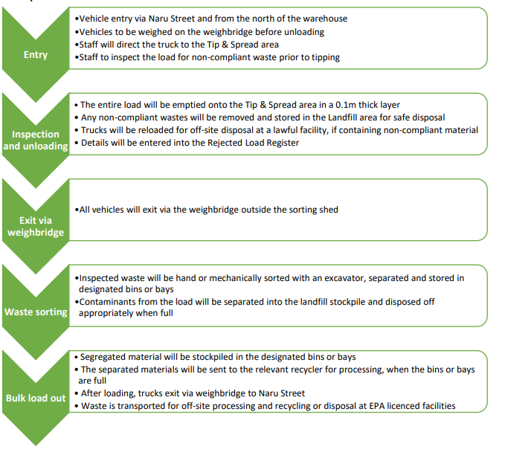

*Figure 1. Flowchart of the Existing WRTS Operations (Jackson Environment and Planning, 2023)*

Further information was sought regarding the operational procedures of the WRTS, particularly with respect to incoming unexpected, contaminated waste. A detailed procedure for the process of managing incoming construction waste is provided within the Waste Management Plan prepared by Jackson Environment and Planning. This procedure has been included below:

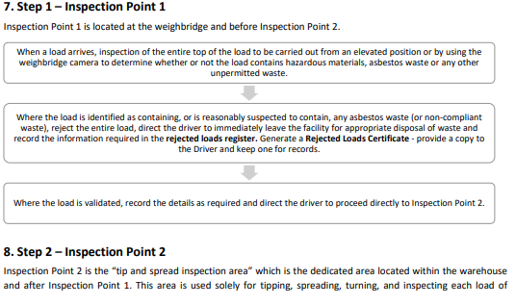

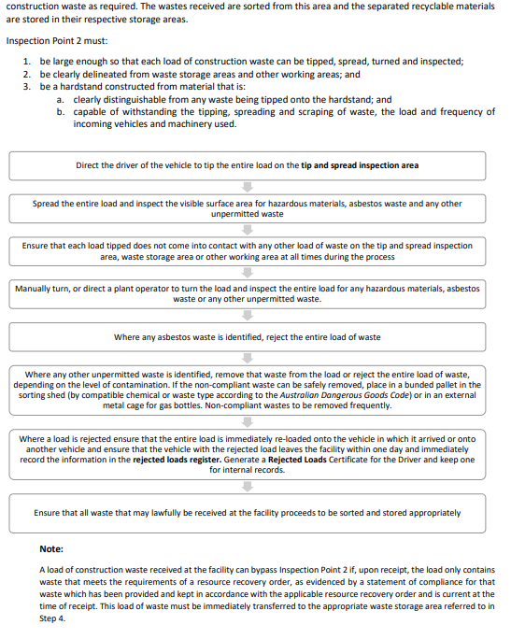

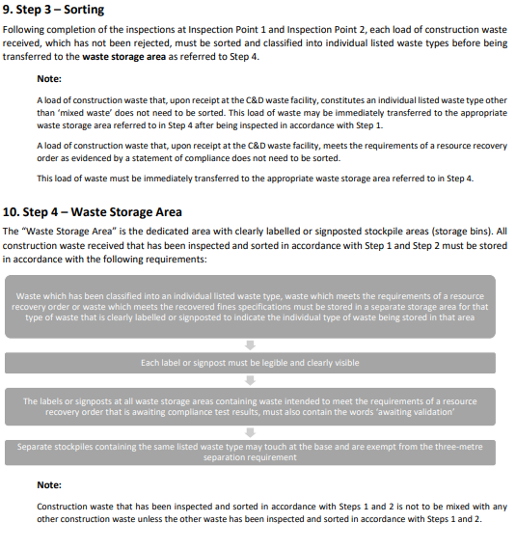

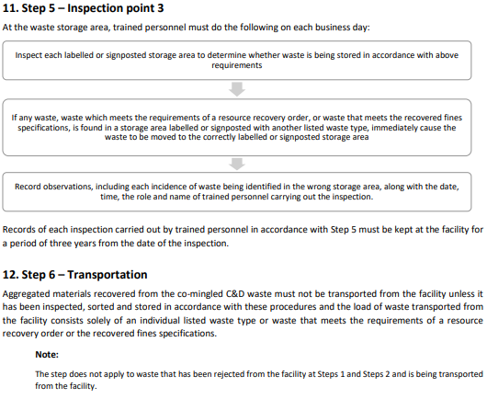

The procedure demonstrates the steps taken in the interrogation of an incoming skip bin. In particular, the steps above outline measures in place for the detection and identification of non-compliant or contaminated waste. Non-compliant waste includes food waste, hazardous waste, asbestos, gas bottles, paints, fuel, oil or chemical containers (or construction wastes which have come into contact with hazardous chemicals) or any other non-permitted waste.

If contaminated waste is detected on entry at Inspection Point 1 (surface inspection at the weighbridge) the load is rejected from the site, recorded in the Rejected Load Register where the load is then transported to a lawful facility that will accept the waste.

Should no contaminated waste be intercepted at Inspection Point 1 the load is then taken to the warehouse for sorting at the “tip and spread inspection area”. This area is used solely for tipping, spreading, turning and inspecting each load of waste. If any contaminated or non-compliant waste is detected at this point, the load is immediately re-loaded onto the vehicle where it is placed on the Rejected Load Register and transported to a lawful facility for disposal from site within one day. If the load contains a minor amount of non-compliant waste which can be separated (e.g., a gas bottle, paint can or an intact package containing chemicals), this waste can be removed and temporarily stored on small bunded pallets or in a metal skip bin, where they will then be transported off-site to a lawful facility for disposal. It is noted that risk of non-complaint waste being received at the site is further minimised, through the inspection of skip bins prior to pick up from customer sites.

The diagram below is a simplified demonstration of the above.

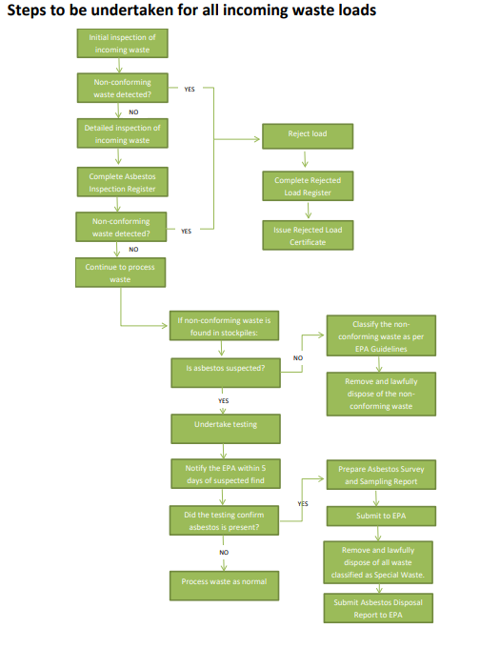

*Figure 2. Steps to be Undertaken for all Incoming Waste Loads (Jackson Environment and Planning, 2023)*

The procedures above are based on the NSW EPA’s *Standards for Managing Construction Waste in NSW,* a best practice guideline. Council’s Environmental Health Officer and the NSW EPA are satisfied with the above measures in interrogating potentially contaminated wastes in incoming loads.

Capacity of the WRTS

Further information was sought regarding the capability of the existing WRTS in meeting the capacity of waste throughput proposed. It is estimated that on average that it takes approximately 10 minutes to inspect, tip, spread and sort materials from a skip bin. Based on this estimation, the WRTS has the capacity to sort waste from 6 skip bins per hour. In order to reach the proposed capacity of 15,000 tonnes per annum, the WRTS would only need to sort 2 skip bins per hour suitably demonstrating there is further capability to meet the proposed capacity. Should 2 or more skip bins arrive at the site at the same time, the sorting shed has additional room for the temporary placement of a skip bin. Once the previous bin’s contents have been sorted and the tip and spread area is clear, the next skip bin can then be emptied, inspected, and sorted.

To meet the maximum capacity of 15,000 tonnes per annum the WRTS needs to receive on average 50 tonnes of waste per day. The Applicant has stated that the site has an overall storage capacity of 104.31 tonnes of waste, exceeding the 50 tonne requirement. The site can therefore store 2 days of waste receipts. This demonstrates adequate storage capacity on site, along with adequate sorting arrangements to meet the maximum capacity of 15,000 tonnes per annum. Council is satisfied that the site has adequate infrastructure and operational controls to meet the increased throughput of waste. The proponent has stated that it is expected that it would take at least five (5) years to meet this capacity limit.

Leachate

Concerns were raised by the NSW EPA over leachate management. Whilst identified as low risk, these concerns related to the stormwater contamination risk from the “storage of wastes (particularly concrete) in bunkers on the outside hardstand area”. The EPA were not satisfied with the original arrangement which include the use of tarpaulins to prevent ingress of rainfall into the bunkers. As the licensee for the proposed upgraded WRTS, the EPA requested further information on the management of leachate. An acceptable resolution was reached between the Applicant and the EPA to require a grated trench drain be provided along the front of the concrete and timber storage bays. This drain will receive any ‘leachate’ created within the storage bays, where it will then be directed to a below-ground impervious concrete sump with a minimum volume of not less than 500 litres. Any captured ‘leachate’ will then be transferred to a lawful facility for disposal. This ensures that no leachate from the timber and concrete storage bays can enter the stormwater system. An updated Soil and Water Impact Assessment Report was provided by the Applicant detailing the above.

Noise

Noise impacts are discussed further in the report. In brief, Council’s Environmental Health Officer along with the NSW EPA are satisfied that suitable arrangements are currently in place and/or proposed to mitigate the impacts of the increased throughput at the WRTS. Conditions have been imposed in NSW EPA GTA’s with respect to noise.

Traffic

A Traffic Impact Assessment Report accompanies the Development Application as prepared by Bitzios Consulting. The report findings conclude a total of 22 heavy vehicle trips (2 trips per hour) a day based on actual traffic data. This calculation is lower than the 24 trips estimated under Development Consent No. DA16/0647 (as amended) which were based on assumptions.

Council’s Traffic Engineer concurs with the findings of the report and raises no objections to the proposal, satisfied with the current arrangements in place. Based on the findings of the report Council’s Traffic Engineer is satisfied that the existing road network is sufficient with no road upgrades required.

The Need

The EIS notes the NSW Waste and Sustainable Materials Strategy 2041 which updated NSW’s previous strategy: the Waste Avoidance and Resource Recovery Strategy 2014–2021.

The EIS states that the proposed upgrades to the WRTS will:

*“help improve recovery of building wastes. The Proposal is strongly aligned with the objectives of the NSW Waste and Sustainable Materials Strategy and will contribute to reducing the amount of waste going to landfill. Recovering resources from wastes contributes to sustainability and in achieving the target of 80% recovery rate from all waste streams by 2030.”*

In addition, the 2018 National Waste Policy provides a framework for collective action by businesses, governments, communities and individuals until 2030. The 2018 National Waste Policy focuses on waste avoidance, improved material recovery and use of recovered materials.

Strategy 7 of the policy aims to increase industry capacity through identifying and addressing opportunities across municipal solid waste, commercial and industrial waste, and construction and demolition waste streams for improved collection, recycling and energy recovery, to deliver ongoing improvements in diversion from landfill, improved quality of recycled content and use of the waste hierarchy.

The EIS notes that: “*The Proposal is aligned with the 2018 National Waste Policy to increase industry capacity through identifying and addressing opportunities for improved collection and deliver on improvements in diversion from landfill in the construction and demolition, timber and garden organics wastes*.”

The facility will recycle an estimated 87% of all incoming waste (~12,977 tonnes per annum) when operating at full capacity contributing to the above targets and to sustainable waste management, particularly within the construction sector within the Shire.

**Locality plan**

*Figure 3. Locality Plan of Subject Site - Tweed Shire Council 2023*

**Site Diagram:**

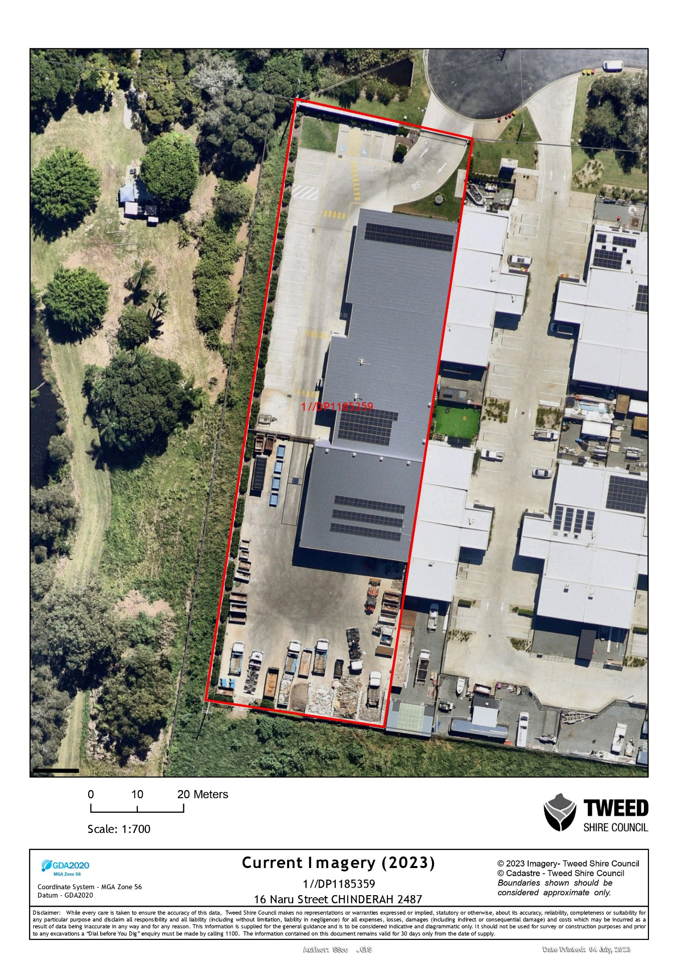

*Figure 4. Aerial Imagery of Subject Site – Tweed Shire Council 2023*

**ZONING MAP:**

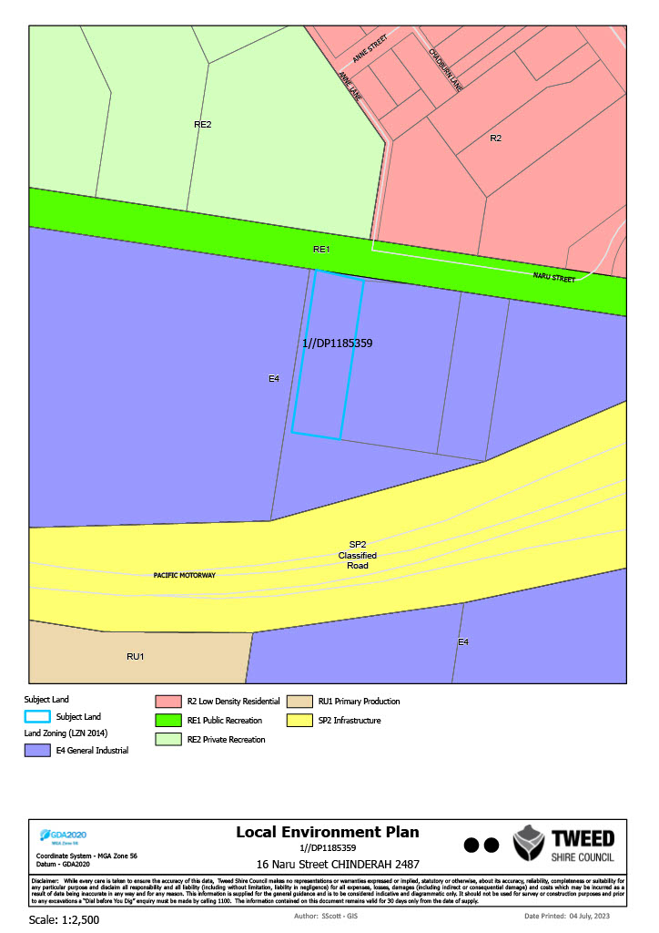

*Figure 5. Zoning Mapping of Subject Site (as Highlighted in Blue) – Tweed Shire Council 2023*

**DEVELOPMENT/ELEVATION PLANS:**

Development plans have not been included with the subject development application. No physical changes are proposed to the WRTS building. Works proposed are confined to; line marking, the instillation of additional fire protection measures, the increase in height of the concrete storage bays by 1m and the addition of a grated trench drain and below-ground impervious concrete sump. Accordingly, development plans are not required.

**CONSIDERATIONS UNDER THE ENVIRONMENTAL PLANNING AND ASSESSMENT ACT REGULATION 2021:**

**Schedule 3 – Designated Development**

Part 2 of Schedule 3 of the *Environmental Planning & Assessment (EP&A) Regulations 2021* relates specifically to the types of development that is considered as Designated Development. If a proposal triggers any of the thresholds associated with a particular use, it is declared to be designated development for the purposes of the EP&A Act and the development application must be accompanied by an Environmental Impact Statement (EIS). In addition, any objectors to the proposal have rights of appeal on merit. An assessment of the clauses of Schedule 3 applicable to the proposed development is noted below.

*45 waste management facilities or works*

(1)  Development for the purposes of a waste management facility or works is designated development if—

(a)  the facility or works dispose of solid or liquid waste by landfilling, thermal treatment, storing, placing or other means, and

(b)  the waste —

(i)  includes a substance classified in the ADG Code or medical, cytotoxic or quarantine waste, or

(ii)  comprises more than 100,000 tonnes of clean fill in a way that, in the consent authority’s opinion, is likely to cause significant impacts on drainage or flooding, or

**Example—**

Clean fill includes soil, sand, gravel, bricks or other excavated or hard material.

(iii)  comprises more than 1,000 tonnes per year of effluent or sludge, or

(iv)  comprises more than 200 tonnes per year of other waste material.

(2)  Development for the purposes of a waste management facility or works is designated development if—

(a)  the facility or works sorts, consolidates or temporarily stores waste at a transfer station or material recycling facility for transfer to another site for final disposal, permanent storage, reprocessing, recycling, use or reuse, and

(b)  the facility or works—

(i)  handle substances classified in the ADG Code or medical, cytotoxic or quarantine waste, or

(ii)  have an intended handling capacity of more than 10,000 tonnes per year of waste containing food or livestock, agricultural or food processing industries waste or similar substances, or

(iii)  have an intended handling capacity of more than 30,000 tonnes per year of waste such as glass, plastic, paper, wood, metal, rubber or building demolition material.

(3)  Development for the purposes of a waste management facility or works that purify, recover, reprocess or process more than 5,000 tonnes per year of solid or liquid organic materials is designated development.

(4)  Development for the purposes of a waste management facility or works is designated development if the facility or works are located—

(a)  in or within 100 metres of a natural waterbody, wetland, coastal dune field or environmentally sensitive area of State significance, or

(b)  in an area of high watertable, highly permeable soils, acid sulfate, sodic or saline soils, or

(c)  in a drinking water catchment, or

(d)  in a catchment of an estuary where the entrance to the sea is intermittently open, or

(e)  on a floodplain, or

(f)  within 500 metres of a residential zone or 250 metres of a dwelling not associated with the development and, in the consent authority’s opinion, considering topography and local meteorological conditions, are likely to significantly affect the amenity of the neighbourhood because of noise, visual impacts, vermin, traffic or air pollution, including odour, smoke, fumes or dust.

(4A)  Despite subsection (4)(f), development for the purposes of waste or resource transfer stations carried out by or on behalf of a public authority is not designated development if the development is carried out—

(a)  within 500m of a residential zone or 250m of a dwelling not associated with the development, and

(b)  under [*State Environmental Planning Policy (Exempt and Complying Development Codes) 2008*](https://legislation.nsw.gov.au/view/html/inforce/current/epi-2008-0572), Part 5A.

(5)  This section does not apply to—

(a)  development comprising or involving the use of effluent or sludge if—

(i)  the dominant purpose is not waste disposal, and

(ii)  the development is carried out in a location other than a location specified in subsection (4), or

(b)  an artificial waterbody located on relevant irrigation land, or

(c)  development comprising or involving waste management facilities or works specifically referred to elsewhere in this Schedule.

The proponent has identified that the provisions of Clause 45(4) (a), (b), (e) and (f) apply.

**Secretary’s Environmental Assessment Requirements (SEAR’s)**

Given that the proposal is Designated Development, the proponent was required to request Secretary’s Environmental Assessment Requirements (SEAR’s) from the Department of Planning & Environment (Department).

The SEAR’s issued by the Department on 5 July 2022 requires the proponent to prepare an Environmental Impact Statement (EIS), including an assessment of all potential impacts of the proposed development on the existing environment (including cumulative impacts if necessary) and develop appropriate measures to avoid, minimise, mitigate and / or manage these potential impacts. The EIS assessment must assess the matters raised in the following table.

|  |  |  |
| --- | --- | --- |
| **Secretary’s Environmental Assessment Requirements (SEAR’s)** | **Proponent Comments** | **Council Comments** |
| **strategic and statutory context** – including:  ­ a detailed justification for the proposal and suitability of the site for the development  ­ a demonstration that the proposal is consistent with all relevant planning strategies, environmental planning instruments, development control plans (DCPs), or justification for any inconsistencies  ­ a list of any approvals that must be obtained under any other Act or law before the development may lawfully be carried out  ­ a description of how the proposed increase to capacity integrates with existing on-site operations  ­ a description of any amendments to and/ or additional licence(s) or approval(s) required to carry out the proposed development. | Addressed in Chapter 19 of the EIS.  Addressed in Chapter 3 of the EIS.  Addressed in Chapter 3 of the EIS.  Addressed in Chapter 2 of the EIS.  Addressed in Chapter 3 of the EIS. | The proponent has provided a detailed justification for the proposal & suitability of the site. It is considered that the proposal is consistent with all applicable legislation. The proponent has provided a list of approvals under other Acts that must be obtained. |
| **suitability of the site** – including:  ­ a detailed justification that the site can accommodate the proposed processing capacity, having regard to the scope of the operations and its environmental impacts and relevant mitigation measures  ­ floor plans depicting the proposed layout, including the location of stockpiles and storage. | Addressed in Chapter 2 and 19 of the EIS. Further information provided in Waste Management Plan.  Addressed in Chapter 2 of the EIS. | The proponent’s EIS has suitably justified that the site can accommodate the proposed processing capacity. |
| **waste management** – including:  ­ details of the type, quantity and classification of waste to be received at the site  ­ details of the resource outputs and any additional processes for residual waste  ­ details of waste handling including, transport, identification, receipt, stockpiling and quality control  ­ the measures that would be implemented to ensure that the proposed development is consistent with the aims, objectives and guidelines in the NSW Waste Avoidance and Sustainable Materials Strategy 2041. | Addressed in 8 of the EIS. Further information provided in Waste Management Plan. | The proponent’s EIS has incorporated a detailed assessment with regard to waste management. Appropriate conditions of consent have been applied. |
| **hazards and risk** – including:  ­ a preliminary risk screening completed in accordance with State Environmental Planning Policy (Resilience and Hazards) 2021, Chapter 3 and Applying SEPP 33 (DoP, 2011), with a clear indication of class, quantity and location of all dangerous goods and hazardous materials associated with the development. Should preliminary screening indicate that the project is "potentially hazardous” a Preliminary Hazard Analysis (PHA) must be prepared in accordance with Hazardous Industry Planning Advisory Paper No. 6 - Guidelines for Hazard Analysis (DoP, 2011) and Multi-Level Risk Assessment (DoP, 2011)  ­ an assessment of flood risk on the site. The assessment should determine: the flood hazard in the area; address the impact of flooding on the proposed development, and the development’s impact (including filling) on flood behaviour of the site and adjacent lands; and address adequate egress and safety in a flood event. | Addressed in Chapter 6 of the EIS.  Addressed in Chapters 7 and 13 of the EIS. | The proponent has undertaken an assessment against Chapter 3 of SEPP (Resilience and Hazards) 2021, including a hazard assessment concluding that the proposal is not considered a hazardous development and as such a PHA is not considered necessary. |
| **fire and incident management** – including:  ­ an assessment of the risk of bushfire, including addressing the requirements of Planning for Bush Fire Protection 2019 (RFS). Any proposed Asset Protection Zones must not adversely affect environmental objectives (e.g. buffers)  ­ technical information on the environmental protection equipment to be installed on the premises such as air, water and noise controls, spill clean-up equipment, fire management (including the location of fire hydrants and water flow rates at the hydrants) and containment measures  ­ details of the size and volume of stockpiles and their arrangements to minimise fire spread and facilitate emergency vehicle access  ­ the measures that would be implemented to ensure that the proposed development is consistent with the aims, objectives and guidelines in the NSW Fire and Rescue guideline Fire Safety in Waste Facilities (FRNSW, 27 February 2020). | Addressed in Chapter 14 of the EIS. Additional information provided in Fire Compliance Report.  Addressed in Chapter 14 of the EIS. Additional information provided in Fire Compliance Report.  Addressed in Chapter 8 of the EIS. Additional information provided in Fire Compliance Report.  Addressed in Chapter 14 of the EIS. Additional information provided in Fire Compliance Report. | The proponent’s EIS has incorporated a detailed assessment with regard to fire and incident management. Under updated 2023 mapping, the subject site is no longer mapped as bushfire prone land. |
| **air quality and odour** – including:  ­ a description of all potential sources of air and odour emissions during operation  ­ an air quality impact assessment in accordance with relevant Environment Protection Authority guidelines, taking into consideration the nearby residential zoned land and the cumulative impacts of the adjoining industry  ­ a description and appraisal of air quality impact mitigation and monitoring measures. | Addressed in Chapter 9 of the EIS. Additional information provided in Air Quality and Odour Impact Assessment. | The proponent has supported the proposed development with an Air Quality Assessment in relation to air quality, and odour. It is considered that the proposed development has satisfactorily addressed the air quality provisions of the SEAR’s, subject to conditions of consent. |
| **noise and vibration** – including:  ­ a description of all potential noise and vibration sources during operation, including road traffic noise  ­ a noise and vibration assessment in accordance with the relevant Environment Protection Authority guidelines, taking into consideration the nearby residential zoned land and the cumulative impacts of adjoining industry  ­ a description and appraisal of noise and vibration mitigation and monitoring measures. | Addressed in Chapter 10 of the EIS. Additional information provided in Environmental Noise Impact Report. | The proponent has supported the proposed development with a Noise Impact Assessment in relation to noise and vibration. It is considered that the proposed development has satisfactorily addressed the noise and vibration provisions of the SEAR’s, subject to conditions of consent. |
| **soil and water** – including:  ­ a description of local soils, topography, drainage and landscapes  ­ details of water usage for the proposal including existing and proposed water licencing requirements in accordance with the Water Act 1912 and/or the Water Management Act 2000  ­ an assessment of potential impacts on floodplain and stormwater management and any impact to flooding in the catchment and confirmation the proposed development would not exacerbate the existing flooding characteristics of adjoining Lot 13  ­ details of sediment and erosion controls  ­ a detailed site water balance  ­ an assessment of potential impacts on the quality and quantity of surface and groundwater resources  ­ wastewater and stormwater management details ensuring there is no overland flow or waste discharge onto Lot 13  ­ a description and appraisal of impact mitigation and monitoring measures. | Addressed in Chapter 13 of the EIS. Additional information provided in Soil and Water Impact Assessment. | The proponent has undertaken a detailed analysis soil and water impacts associated with the proposed development. Appropriate conditions have been applied, including GTA’s from the EPA, which relate specifically to leachate management and stormwater discharge. |
| **traffic and transport** – including:  ­ details of road transport routes and access to the site  ­ road traffic predictions for the development during operation  ­ swept path diagrams depicting vehicles entering, exiting and manoeuvring throughout the site  ­ an assessment of impacts to the safety and function of the road network and the details of any road upgrades required for the development  ­ consideration of the cumulative impact of the proposed development and the potential future development of Lot 13 having regard to the capacity of Naru Street and noting the cul-de-sac location. | Addressed in Chapter 11 of the EIS. Additional information provided in Traffic and Transport Impact Assessment. | The proponent has prepared a Traffic Impact Assessment which addresses the suitability of the site, traffic impacts and road upgrade requirements. Applicable conditions of consent have been applied where required. |
| **community and stakeholder engagement** – including:  ­ a detailed community and stakeholder participation strategy which identifies who in the community has been consulted and a justification for their selection, other stakeholders consulted and the form(s) of the consultation, including a justification for this approach  ­ a report on the results of the implementation of the strategy including issues raised by the community and surrounding occupiers and landowners that may be impacted by the proposal  ­ details of how issues raised during community and stakeholder consultation have been addressed and whether they have resulted in changes to the proposal  ­ details of the proposed approach to future community and stakeholder engagement based on the results of the consultation. | Addressed in Chapter 5 of the EIS. Additional information provided in Consultation Plan and Report. | The proponent’s EIS has incorporated a detailed assessment with regard to community and stakeholder engagement. |
| **biodiversity** – including a description of any potential vegetation clearing needed to undertake the proposal and any impacts on flora and fauna. | Addressed in Chapter 12 of the EIS. Additional information provided in Biodiversity Impact Assessment. | The proposed development is considered to have satisfactorily addressed all of the SEAR’s requirements with regard to biodiversity. |
| **visual** – including an impact assessment at private receptors and public vantage points. Consideration should be given to any external stockpile area arising from the intensification of the use of the site. | Addressed in Chapter 16 of the EIS. Additional information provided in Visual Impact Assessment. | The proponent has undertaken an assessment of potential visual impacts associated with the development. |
| **heritage** – including an assessment of Aboriginal and non-Aboriginal cultural heritage | Addressed in Chapter 15 of the EIS. | The proponent has undertaken a review of the proposed development in terms of Aboriginal and non Aboriginal cultural heritage. Council officers are satisfied with the assessment. |

1. **STATUTORY CONSIDERATIONS**

When determining a development application, the consent authority must take into consideration the matters outlined in Section 4.15(1) of the *Environmental Planning and Assessment Act 1979* (‘EP&A Act’). These matters as are of relevance to the development application include the following:

1. *the provisions of any environmental planning instrument, proposed instrument, development control plan, planning agreement and the regulations*

*(i)  any environmental planning instrument, and*

*(ii)  any proposed instrument that is or has been the subject of public consultation under this Act and that has been notified to the consent authority (unless the Planning Secretary has notified the consent authority that the making of the proposed instrument has been deferred indefinitely or has not been approved), and*

*(iii)  any development control plan, and*

*(iiia)  any planning agreement that has been entered into under section 7.4, or any draft planning agreement that a developer has offered to enter into under section 7.4, and*

*(iv)  the regulations (to the extent that they prescribe matters for the purposes of this paragraph),*

*that apply to the land to which the development application relates,*

1. *the likely impacts of that development, including environmental impacts on both the natural and built environments, and social and economic impacts in the locality,*
2. *the suitability of the site for the development,*
3. *any submissions made in accordance with this Act or the regulations,*
4. *the public interest.*

These matters are further considered below.

It is noted that the proposal is considered to be (which are considered further in this report):

* Integrated Development (s4.46)
* Designated Development (s4.10)
* Requiring concurrence/referral (s4.13)
  1. **Environmental Planning Instruments, proposed instrument, development control plan, planning agreement and the regulations**

The relevant environmental planning instruments, proposed instruments, development control plans, planning agreements and the matters for consideration under the Regulation are considered below.

1. **Section 4.15(1)(a)(i) - Provisions of Environmental Planning Instruments**

The following Environmental Planning Instruments are relevant to this application:

* [*State Environmental Planning Policy (Planning Systems) 2021*](https://legislation.nsw.gov.au/view/html/inforce/current/epi-2021-0724)
* [*State Environmental Planning Policy (Resources and Energy) 2021*](https://legislation.nsw.gov.au/view/html/inforce/current/epi-2021-0731)
* [*State Environmental Planning Policy (Transport and Infrastructure) 2021*](https://legislation.nsw.gov.au/view/html/inforce/current/epi-2021-0732)
* *Tweed Local Environmental Plan 2014;*

A summary of the key matters for consideration arising from these State Environmental Planning Policies are outlined in **Table 3** and considered in more detail below.

**Table 3: Summary of Applicable Environmental Planning Instruments**

|  |  |  |
| --- | --- | --- |
| **EPI** | **Matters for Consideration** | **Comply (Y/N)** |
| State Environmental Planning Policy (Planning Systems) 2021 | Chapter 2: State and Regional Development   * Section 2.19(1) declares the proposal regionally significant development pursuant to Clause 5 of Schedule 6 as it comprises waste management facilities or works that meet the requirements for designated development under the Environmental Planning and Assessment Regulation 2021, Schedule 3, Section 45. | Y |
| SEPP (Resilience & Hazards) | Chapter 2: Coastal Management   * Section 2.10(1) & (2) - Development on land within the coastal environment area   Chapter 3: Hazardous and Offensive Development   * Part 3 Potentially hazardous or potentially offensive development – A preliminary hazard analysis has been prepared. Based on this analysis is determined that the proposal is not considered a potentially hazardous development.   Chapter 4: Remediation of Land   * Section 4.6 - Contamination and remediation has been considered in the Contamination Report and the proposal is satisfactory subject to conditions. | Y |
| State Environmental Planning Policy (Transport and Infrastructure) 2021 | Chapter 2: Infrastructure   * Section 2.48(2) (Determination of development applications—other development) – electricity transmission - the proposal is satisfactory subject to conditions. * Section 2.122 - Traffic-generating development – No objection to or requirements for the proposed development. | Y  Y |
| LEP | * Clause 1.2 – Aims of the Plan * Clause 2.3 – Zone objectives and Land Use Table * Clause 4.3 – Height of buildings * Clause 4.6 – Exceptions to development standards * Clause 5.10 – Heritage conservation * Clause 7.1 – Acid sulfate soils * Clause 7.2 – Earthworks * Clause 7.3 – Flood planning * Clause 7.6 – Stormwater management * Clause 7.8 – Airspace operations * Clause 7.10 – Essential services | Y  Y  Y  Y  Y  Y  Y  Y  Y  Y  Y |
| DCP | * *Section A2 – Site Access and Parking Code* * *Section A3 – Development of Flood Liable Land* * *Section A13* – *Socio-Economic Impact Assessment* * *Section A15 – Waste Management*   *Section A17* – *Business, Enterprise Corridor and General Industrial Zones* | Y  Y  Y  Y  Y |

Consideration of the relevant SEPPs is outlined below:

[*State Environmental Planning Policy (Planning Systems) 2021*](https://legislation.nsw.gov.au/view/html/inforce/current/epi-2021-0724) *(‘*Planning Systems SEPP’)

Chapter 2: State and Regional Development

The proposal is *regionally significant development* pursuant to Section 2.19(1) as it satisfies the criteria in Clause 5 of Schedule 6 of the Planning Systems SEPP as the proposal is development for a waste management facility or works that meet the requirements for designated development under the Environmental Planning and Assessment Regulation 2021, Schedule 3, Section 45.Accordingly, the Northern Regional Planning Panel is the consent authority for the application. The proposal is consistent with this Policy.

[*State Environmental Planning Policy (Resilience and Hazards) 2021*](https://legislation.nsw.gov.au/view/html/inforce/current/epi-2021-0730)

Chapter 2: Coastal Management

The subject site is mapped as being within the Coastal Environment Area.

The provisions of each clause are as follows:

*2.10 Development on land within the coastal environment area*

*(1) Development consent must not be granted to development on land that is within the coastal environment area unless the consent authority has considered whether the proposed development is likely to cause an adverse impact on the following:*

*(a) the integrity and resilience of the biophysical, hydrological (surface and groundwater) and ecological environment,*

*(b) coastal environmental values and natural coastal processes,*

*(c) the water quality of the marine estate (within the meaning of the* [*Marine Estate Management Act 2014*](https://www.legislation.nsw.gov.au/#/view/act/2014/72)*), in particular, the cumulative impacts of the proposed development on any of the sensitive coastal lakes identified in Schedule 1,*

*(d) marine vegetation, native vegetation and fauna and their habitats, undeveloped headlands and rock platforms,*

*(e) existing public open space and safe access to and along the foreshore, beach, headland or rock platform for members of the public, including persons with a disability,*

*(f) Aboriginal cultural heritage, practices and places,*

*(g) the use of the surf zone.*

*(2) Development consent must not be granted to development on land to which this clause applies unless the consent authority is satisfied that:*

*(a) the development is designed, sited and will be managed to avoid an adverse impact referred to in subclause (1), or*

*(b) if that impact cannot be reasonably avoided—the development is designed, sited and will be managed to minimise that impact, or*

*(c) if that impact cannot be minimised—the development will be managed to mitigate that impact.*

*(3) This clause does not apply to land within the Foreshores and Waterways Area within the meaning of* [*Sydney Regional Environmental Plan (Sydney Harbour Catchment) 2005*](https://www.legislation.nsw.gov.au/#/view/EPI/2005/590)*.*

Consistent with the approved development under Development Consent No. DA16/0647 (as amended) it is not considered that the proposed upgrade works will result in any unacceptable impacts on the coastal environment.

The proposal is not considered to create adverse impacts on the integrity and resilience of the biophysical, hydrological and ecological environment of the area, including the nearby coastal wetlands. Adequate stormwater management is provided ensuring that the proposal does not negatively impact the quality and quality of surface and ground water flows. Further, the subject site is not located adjacent to a foreshore area and the proposal will therefore not impact on access to and along the foreshore or use of the surf zone. The proposed development will not impact upon Aboriginal cultural heritage, practices or places.

The proposal is not in conflict with the SEPP and is considered acceptable.

2.13 Development in coastal zone generally—coastal management programs to be considered

Tweed Shire Coastline Management Plan 2005

This Plan applies to the Shire’s 37 kilometre coastline and has a landward boundary that includes all lands likely to be impacted by coastline hazards plus relevant Crown lands. The primary objectives of the Coastal Management Plan are to protect development; to secure persons and property; and to provide, maintain and replace infrastructure.

The proposed development is not considered to impact upon that coastline with regard to demands and issues identified within the Plan for the whole of the Tweed coastline (Clause 2.4.1) including: recreation; water quality; heritage; land use and development potential; coastal ecology and, social and economic demand. Under this plan, the subject site is not identified as having any key management actions or specific management strategies. The proposal is considered to be consistent with the objectives of the Management Plan.

Coastal Zone Management Plan for Cobaki and Terranora Broadwater (adopted by Council at the 15 February 2011 meeting)

This Plan applies to the Cobaki and Terranora Broadwater and does not apply to the subject site.

Coastal Zone Management Plan Tweed Coast Estuaries 2013

This Plan applies to the Cudgen Creek and Cudgen Lake, Cudgera Creek and Mooball Creek systems and does not apply to the subject site.

Kingscliff – Dreamtime Coastal Zone Management Plan

This Plan applies to the Kingscliff – Dreamtime Beach embayment. The subject site is not located in an area bound by this Plan and therefore does not apply to the subject site.

Tweed River Estuary Coastal Management Program

Tweed River is located approximately 590m to the west of the property, in what would be labelled as the Lower Estuary under the *Tweed River Estuary Coastal Management Program.* Council is satisfied that the proposed development will not negatively impact the Tweed River, with suitable measures in place to mitigate impacts on the natural environment.

Chapter 3: Hazardous and offensive development

**Part 3 Potentially hazardous or potentially offensive development**

**3.10**   **Development to which Part 3 applies**

*(1)  This Part applies to—*

*(a)  development for the purposes of a potentially hazardous industry, and*

*(b)  development for the purposes of a potentially offensive industry, and*

*(c)  development notified, for the purposes of this Part, by the Director in the Gazette as being a potentially hazardous or potentially offensive development.*

*(2)  This Part does not apply to development the subject of a development application made before the date on which this Chapter takes effect.*

**3.11**   **Preparation of preliminary hazard analysis**

*A person who proposes to make a development application to carry out development for the purposes of a potentially hazardous industry must prepare (or cause to be prepared) a preliminary hazard analysis in accordance with the current circulars or guidelines published by the Department of Planning and submit the analysis with the development application.*

As per the findings of the hazards assessment within the EIS, the proposed development is not considered a potentially hazardous development as per the SEPP Guidelines, therefore, no further Preliminary Hazard Analysis or Multi-Level Risk Assessment is required.

Clause 3.12 of Chapter 3 of the SEPP provides for certain matters that the consent authority must consider in determining the proposed development. Council’s assessment against the provisions of Clause 3.12 of Chapter 3 of SEPP (Resilience and Hazards) 2021 is noted below.

**3.12**   **Matters for consideration by consent authorities**

*In determining an application to carry out development to which this Part applies, the consent authority must consider (in addition to any other matters specified in the Act or in an environmental planning instrument applying to the development)—*

1. *current circulars or guidelines published by the Department of Planning relating to hazardous or offensive development, and*

The proponent has addressed relevant guidelines published by the Department of Planning relating to hazardous or offensive development. The proposed development is not classified as a potentially hazardous industry.

1. *whether any public authority should be consulted concerning any environmental and land use safety requirements with which the development should comply, and*

The proposed development was referred to the EPA for approval. Following a detailed review process, with particular regard to leachate management and stormwater discharge, general terms of approval have been issued by the EPA. The application was also referred to other public authorities for comment, as noted later in this report.

1. *in the case of development for the purpose of a potentially hazardous industry—a preliminary hazard analysis prepared by or on behalf of the applicant, and*

The proponent’s assessment identified that the proposed development is not classified as a potentially hazardous industry. No further assessment is considered necessary in this regard.

1. *any feasible alternatives to the carrying out of the development and the reasons for choosing the development the subject of the application (including any feasible alternatives for the location of the development and the reasons for choosing the location the subject of the application), and*

The proponent has not provided an assessment of alternative options for development of the site. Feasible alternatives to development have been considered by Council. However, as discussed in this report the WRTS upgrades will contribute positively to state and federal waste targets, especially in relation to recycling.

*(e)  any likely future use of the land surrounding the development*.

Adjoining land uses are zoned General Industrial and are utilised for such purposes. This land is safely assumed to remain zoned for such purposes in the future.

Council officers are satisfied that proposed development is not a hazardous industry. The EPA has assessed the proposal with regard to such strategies and has issued general terms of approval for the proposed development. As such, the proposed development is considered to meet the specific provisions of Chapter 3 of SEPP (Resilience and Hazards) 2021.

Chapter 4: Remediation of Land

The provisions of Chapter 4 of *State Environmental Planning Policy (Resilience and Hazards) 2021 (‘the* Resilience and Hazards SEPP’) have been considered in the assessment of the development application. Section 4.6 of Resilience and Hazards SEPP requires consent authorities to consider whether the land is contaminated, and if the land is contaminated, it is satisfied that the land is suitable in its contaminated state (or will be suitable, after remediation) for the purpose for which the development is proposed to be carried out.

In relation to SEPP (Resilience and Hazards) 2021 requirements, Environmental Health Officer comments for the original application DA16/0647 confirmed “the site was assessed by the EH Unit as suitable for industrial sub-division as given in DA09/0006. No further information or investigation in relation to past potentially contaminating activities is required”. Contamination of land has been considered and is not considered a constraint for the proposal.

[*State Environmental Planning Policy (Transport and Infrastructure) 2021*](https://legislation.nsw.gov.au/view/html/inforce/current/epi-2021-0732)

*Chapter 2: Infrastructure*

**2.122 Traffic generating development**

*(4)  Before determining a development application for development to which this section applies, the consent authority must—*

*(a)  give written notice of the application to TfNSW within 7 days after the application is made, and*

*(b)  take into consideration—*

*(i)  any submission that RMS provides in response to that notice within 21 days after the notice was given (unless, before the 21 days have passed, TfNSW advises that it will not be making a submission), and*

*(ii)  the accessibility of the site concerned, including—*

*(A)  the efficiency of movement of people and freight to and from the site and the extent of multi-purpose trips, and*

*(B)  the potential to minimise the need for travel by car and to maximise movement of freight in containers or bulk freight by rail, and*

*(iii)  any potential traffic safety, road congestion or parking implications of the development.*

TfNSW has provided comments on the proposed development, to assist the consent authority in making a determination, commenting the following:

“*TfNSW has reviewed the information provided and raises no objection to or requirements for the proposed development as it is considered there will be no significant impact on the nearby classified (State) road network*”.

Council’s Traffic Engineer raises no objection to the proposed development with respect to the accessibility of the site.

It is considered that the proposed development meets the specific provisions of clause 2.122.

**2.48 Determination of development applications – other development**

*(1) This section applies to a development application (or an application for modification of a consent) for development comprising or involving any of the following—*

*(a) the penetration of ground within 2m of an underground electricity power line or an electricity distribution pole or within 10m of any part of an electricity tower,*

*(b) development carried out—*

*(i) within or immediately adjacent to an easement for electricity purposes (whether or not the electricity infrastructure exists), or*

*(ii) immediately adjacent to an electricity substation, or*

*(iii) within 5m of an exposed overhead electricity power line,*

*(c) installation of a swimming pool any part of which is—*

*(i) within 30m of a structure supporting an overhead electricity transmission line, measured horizontally from the top of the pool to the bottom of the structure at ground level, or*

*(ii) within 5m of an overhead electricity power line, measured vertically upwards from the top of the pool,*

*(d) development involving or requiring the placement of power lines underground, unless an agreement with respect to the placement underground of power lines is in force between the electricity supply authority and the council for the land concerned.*

*(2) Before determining a development application (or an application for modification of a consent) for development to which this section applies, the consent authority must—*

*(a) give written notice to the electricity supply authority for the area in which the development is to be carried out, inviting comments about potential safety risks, and*

*(b) take into consideration any response to the notice that is received within 21 days after the notice is given.*

In accordance with clause 2, the development application was referred to Essential Energy who provided the following comments:

*Strictly based on the documents submitted, Essential Energy has the following comments to make as to potential safety risks arising from the proposed development:*

* + - *As the plans provided do not show the distances from Essential Energy’s infrastructure and the development, there may be a safety risk. A distance of 9.3 m from the nearest part of the development to Essential Energy’s infrastructure (measured horizontally) is required to ensure that there is no safety risk.*

***66Kv overhead power line running North, South along the Western boundary of the property.***

* + - *It is also essential that all works comply with SafeWork clearance requirements. In this regard it is the responsibility of the person/s completing any works to understand their safety responsibilities. The applicant will need to submit a Request for Safety Advice if works cannot maintain the safe working clearances set out in the Working Near Overhead Powerlines Code of Practice, or CEOP8041 - Work Near Essential Energy's Underground Assets.*

*Information relating to developments near electrical infrastructure is available on our website Development Applications (essentialenergy.com.au). If the applicant believes the development complies with safe distances or would like to submit a request to encroach then they will need to complete a Network Encroachment Form via Essential Energy’s website Encroachments (essentialenergy.com.au) and provide supporting documentation. Applicants are advised that fees and charges will apply where Essential Energy provides this service.*

*Council’s and the applicant’s attention is also drawn to Section 49 of the Electricity Supply Act 1995 (NSW). Relevantly, Essential Energy may require structures or things that could destroy, damage or interfere with electricity works, or could make those works become a potential cause of bush fire or a risk to public safety, to be modified or removed.*

Essential Energy makes the following general comments:

* *If the proposed development changes, there may be potential safety risks and it is recommended that Essential Energy is consulted for further comment;*
* *Any existing encumbrances in favour of Essential Energy (or its predecessors) noted on the title of the above property should be complied with;*
* *Any activities in proximity to electrical infrastructure must be undertaken in accordance with the latest industry guideline currently known as ISSC 20 Guideline for the Management of Activities within Electricity Easements and Close to Infrastructure;*
* *Prior to carrying out any works, a “Dial Before You Dig” enquiry should be undertaken in accordance with the requirements of Part 5E (Protection of Underground Electricity Power Lines) of the Electricity Supply Act 1995 (NSW); the location of overhead and underground powerlines are also shown in the Look Up and Live app essentialenergy.com.au/lookupandlive.*

Noting the above the proposed development application works are minor limited to line marking, the instillation of additional fire protection measures, the increase in height of the concrete storage bays by 1m and the addition of a grated trench drain and below-ground impervious concrete sump. Accordingly, impacts to the overhead power line are not likely. Nonetheless, Essential Energy’s comments as to potential safety risks and the additional comments as noted above have been conditioned.

Clause 2.48 is considered satisfied.

*Tweed Local Environmental Plan 2014*

The relevant local environmental plan applying to the site is the *Tweed Local Environmental Plan 2014* (‘the LEP’).

Clause 1.2 - Aims of the Plan

The aims of this plan as set out under Section 1.2 of this plan are as follows:

(1) This Plan aims to make local environmental planning provisions for land in Tweed in accordance with the relevant standard environmental planning instrument under section 3.20 of the Act.

(2) The particular aims of this Plan are as follows:

*(aa)  to protect and promote the use and development of land for arts and cultural activity, including music and other performance arts,*

*(a)  to give effect to the desired outcomes, strategic principles, policies and actions contained in the Council’s adopted strategic planning documents, including, but not limited to, consistency with local indigenous cultural values, and the national and international significance of the Tweed Caldera,*

*(b)  to encourage a sustainable local economy and small business, employment, agriculture, affordable housing, recreational, arts, social, cultural, tourism and sustainable industry opportunities appropriate to Tweed,*

*(c)  to promote the responsible sustainable management and conservation of Tweed’s natural and environmentally sensitive areas and waterways, visual amenity and scenic routes, built environment, and cultural heritage,*

*(d)  to promote development that is consistent with the principles of ecologically sustainable development and to implement appropriate action on climate change,*

*(e)  to promote building design which considers food security, water conservation, energy efficiency and waste reduction,*

*(f)  to promote the sustainable use of natural resources and facilitate the transition from fossil fuels to renewable energy,*

*(g)  to conserve or enhance the biological diversity, scenic quality and geological and ecological integrity of Tweed,*

*(h)  to promote the management and appropriate use of land that is contiguous to or interdependent on land declared a World Heritage site under the Convention Concerning the Protection of World Cultural and Natural Heritage, and to protect or enhance the environmental significance of that land,*

*(i)  to conserve or enhance areas of defined high ecological value,*

*(j)  to provide special protection and suitable habitat for the recovery of the Tweed coastal Koala.*

The proposed development is considered to be generally in accordance with the aims of this plan having regard to its nature, permissibility at this location and subject to the application of recommended conditions of consent.

Clause 1.4 – Definitions

Under this Plan, the proposed development is a “waste or resource management facility”, defined as follows;

***waste or resource management facility*** *means any of the following:*

*(a) a resource recovery facility,*

*(b) a waste disposal facility,*

*(c) a waste or resource transfer station,*

*(d) a building or place that is a combination of any of the things referred to in paragraphs (a)–(c).*

A “waste or resource transfer station” is defined as follows:

***waste or resource transfer station*** *means a building or place used for the collection and transfer of waste material or resources, including the receipt, sorting, compacting, temporary storage and distribution of waste or resources and the loading or unloading of waste or resources onto or from road or rail transport.*

This use is permitted with consent in the E4 General Industrial zone.

Clause 2.3 – Zone objectives and Land use table

The objectives of the E4 General Industrial zone are:

* To provide a range of industrial, warehouse, logistics and related land uses.
* To ensure the efficient and viable use of land for industrial uses.
* To minimise any adverse effect of industry on other land uses.
* To encourage employment opportunities.
* To enable limited non-industrial land uses that provide facilities and services to meet the needs of businesses and workers.

The proposed development is considered to be consistent with the above objectives, by virtue of an industrial land use, encouraging employment opportunities and by protecting industrial land for industrial uses.

Clause 4.3– Height of Buildings

TLEP 2014 provides for a 10m building height limit for the subject site. No changes are proposed to the approved building height of the WRTS.

Clause 4.4 – Floor Space Ratio

Floor Space Ratio provisions associated with clause 4.4 are not applicable to the subject site.

Clause 4.6- Exceptions to development standards

*(3) Development consent must not be granted for development that contravenes a development standard unless the consent authority has considered a written request from the applicant that seeks to justify the contravention of the development standard by demonstrating—*

*(a) that compliance with the development standard is unreasonable or unnecessary in the circumstances of the case, and*

*(b) that there are sufficient environmental planning grounds to justify contravening the development standard.*

*(4) Development consent must not be granted for development that contravenes a development standard unless—*

*(a) the consent authority is satisfied that—*

*(i) the applicant’s written request has adequately addressed the matters required to be demonstrated by subclause (3), and*

*(ii) the proposed development will be in the public interest because it is consistent with the objectives of the particular standard and the objectives for development within the zone in which the development is proposed to be carried out, and*

*(b) the concurrence of the Planning Secretary has been obtained.*

No exceptions to the development standards are sought.

Clause 5.4 – Controls relating to miscellaneous permissible uses

No controls applicable to a WRTS.

Clause 5.10 – Heritage Conservation

The objectives of this clause are as follows—

1. *to conserve the environmental heritage of Tweed,*
2. *to conserve the heritage significance of heritage items and heritage conservation areas, including associated fabric, settings and views,*
3. *to conserve archaeological sites,*
4. *to conserve Aboriginal objects and Aboriginal places of heritage significance.*

Heritage was considered at length under the original consent (Development Consent No. DA16/0647). It was determined that the site was highly disturbed with no evidence of any Aboriginal artifacts. The subject site is not mapped as a known or predictive location of Aboriginal cultural heritage significance.

Council officers have reviewed the proposal with regard to clause 5.10 (8) if the *TLEP 2014*. Given minimal works are proposed, no further assessment is considered necessary and referral to the Tweed Byron Local Aboriginal Land Council (TBLALC) is not required. A standard condition has been applied as a precautionary approach in the event of any unexpected finds during construction activities. Accordingly, the proposed development is considered to satisfy the provisions of clause 5.10.

Clause 5.11 – Bush fire hazard reduction

The subject site is not mapped as bushfire prone land under 2023 mapping. No further consideration required.

Clause 5.21 – Flood Planning

(1)  The objectives of this clause are as follows—

*(a)  to minimise the flood risk to life and property associated with the use of land,*

*(b)  to allow development on land that is compatible with the flood function and behaviour on the land, taking into account projected changes as a result of climate change,*

*(c)  to avoid adverse or cumulative impacts on flood behaviour and the environment,*

*(d)  to enable the safe occupation and efficient evacuation of people in the event of a flood.*

*(2)  Development consent must not be granted to development on land the consent authority considers to be within the flood planning area unless the consent authority is satisfied the development—*

*(a)  is compatible with the flood function and behaviour on the land, and*

*(b)  will not adversely affect flood behaviour in a way that results in detrimental increases in the potential flood affectation of other development or properties, and*

*(c)  will not adversely affect the safe occupation and efficient evacuation of people or exceed the capacity of existing evacuation routes for the surrounding area in the event of a flood, and*

*(d)  incorporates appropriate measures to manage risk to life in the event of a flood, and*

*(e)  will not adversely affect the environment or cause avoidable erosion, siltation, destruction of riparian vegetation or a reduction in the stability of river banks or watercourses.*

*(3)  In deciding whether to grant development consent on land to which this clause applies, the consent authority must consider the following matters—*

*(a)  the impact of the development on projected changes to flood behaviour as a result of climate change,*

*(b)  the intended design and scale of buildings resulting from the development,*

*(c)  whether the development incorporates measures to minimise the risk to life and ensure the safe evacuation of people in the event of a flood,*

*(d)  the potential to modify, relocate or remove buildings resulting from development if the surrounding area is impacted by flooding or coastal erosion.*

The subject site is mapped as being inundated by the 1 in 100 year flood event (1% AEP) and therefore is within a flood planning area.

The WRTS was assessed against Clause 7.3 during assessment of Development Consent No. DA16/0647. Under this application Council officers were satisfied that the development including the acoustic fencing “will have no significant impact on flood levels in the locality”. No objections were raised to the development on flooding grounds.

In assessing the subject development application, Council’s flood engineer has determined that no further considerations to flood impacts are required given that the upgrade does not propose any changes to the existing building or fencing. As required by Clause 5.21 (3), Council has considered the proposed development in terms of flood planning. It is considered that Clause 5.21 has been satisfied.

Clause 7.1 – Acid Sulfate Soils

The subject site demonstrates Class 3 Acid Sulfate Soils (ASS) in accordance with the provisions of this clause. The objective of this clause is to ensure that development does not disturb, expose or drain acid sulfate soils and cause environmental damage.

The application has been reviewed by Councils Environmental Health Section who have provided the following comment with respect to Acid Sulfate Soils;

*“As no physical works are proposed, acid sulfate soil is not considered a constraint for the proposal.”*

In this regard, the proposal is considered to be acceptable with respect to the acid sulfate soils on site and the provisions of this clause.

Clause 7.2 – Earthworks

The objective of this clause is to ensure that earthworks for which development consent is required will not have a detrimental impact on environmental functions and processes, neighbouring uses, cultural or heritage items or features of the surrounding land.

No site filling or significant earthworks are proposed. Earthworks are limited and are only required for the grated trench drain and below-ground concrete sump. It is not considered that these works will have a detrimental impact on environmental functions and processes, nor will they impact upon neighbouring land uses, cultural or heritage items or features of the surrounding land. Accordingly, the subject application is considered to be acceptable having regard to the provisions of clause 7.2.

Clause 7.4 – Floodplain risk management

(1) The objectives of this clause are as follows—

1. *in relation to development with particular evacuation or emergency response issues, to enable evacuation of land subject to flooding in events exceeding the flood planning level,*
2. *to protect the operational capacity of emergency response facilities and critical infrastructure during extreme flood events*

Waste or resource transfer centres are not included as development to which Clause 7.4 applies. No further consideration required.

Clause 7.6 – Stormwater Management

The objective of this Clause is to minimise the impacts of stormwater on land to which this clause applies and on adjoining properties, native bushland and receiving waters.

The proposal was referred internally to Council’s Roads and Stormwater Unit for their review. Council’s Stormwater Engineer is satisfied that existing stormwater arrangements under Development Consent No. DA16/0647 and stormwater drainage application SWD18/0570 for the WRTS remain satisfactory with no further stormwater measures required. Accordingly, the proposal is considered to be acceptable with respect to the requirements of this clause.

Clause 7.10 – Essential Services

This clause outlines that consent must not be granted to development unless the consent authority is satisfied that essential services such as water, electricity, sewerage, stormwater drainage and vehicular access are available or that adequate arrangements have been made to make them available when required.

Council is satisfied that all essential services are available at the subject site. As such the proposal is acceptable with respect to the provisions of this clause.

1. **Section 4.15(1)(a)(iii) - Provisions of any Development Control Plan**

The following Development Control Plan is relevant to this application:

* *Tweed Development Control Plan 2014* (‘the DCP’)

A2-Site Access and Parking Code

The aims of this Section are to:

* Provide safe, convenient and equitable access to developed land for pedestrians, cyclists, motorists and public transport users.
* Provide facilities and infrastructure that encourage movement by means other than private vehicle.
* Encourage car park design and landscaping to enhance visual amenity, provide pedestrian comfort, legibility and minimise impacts from stormwater runoff and pollution.
* Provide off street parking facilities that satisfy the demand of residents, visitors, staff, customers, servicing, loading and unloading.
* Provide integrated transport opportunities within business centres to improve their amenity, accessibility and sustainability.

**Access:**

The existing WRTS is accessed via Naru Street. Naru Street is a local street which provides access to the site, adjacent industrial uses, and a Child Care Centre on the corner of Chinderah Road. Chinderah Road intersects with Naru Street and is a local arterial road that provides access to the Pacific Motorway and Tweed Coast Road to the south.

Site access is to remain as approved under Development Consent No. DA16/0647 (as amended). Accordingly, the site remains to demonstrate adequate access arrangements and traffic circulation. Council’s Traffic Engineer remains satisfied with site access and the internal movement arrangements.

**Parking:**

The following car parking rates were approved under Development Consent No. DA16/0647:

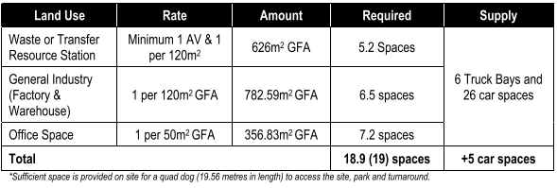

Figure . Approved Parking Rates under Development Consent No. DA16/0647

No changes are proposed to the approved parking provisions on site given there is no increase in floor area of the WRTS. Council’s Traffic Engineer has reviewed the parking assessment within the Traffic Assessment Report prepared by Bitzios Consulting and is satisfied with the provision of parking on site, with 5 additional parking spaces present on site as per the original approval under Development Consent No. DA16/0647.

The proposed development is considered to comply with the access and parking requirements stipulated in Tweed DCP A2.

A3-Development of Flood Liable Land

Council officers have undertaken a review of the proposal against the provisions Section A3. No changes are proposed to the external building or to the existing approved stormwater management of the approved development.

Council’s Flooding Engineer in the Roads and Stormwater Unit has provided the following with respect to flooding:

*“As flooding have previously been dealt with under Development Consent No. DA16/0647 and the upgrade does not propose changes to the existing building or fencing no conditions are required. “*

The proposed developed continues to comply with the provisions of Section A3 of the DCP.

A13 - Socio-Economic Impact Assessment

Section A13 requires a socio-economic assessment to accompany any application that is Designated Development, however, it is also stated that if the impacts are considered negligible then Council may determine that a Socio-Economic Impact Assessment is not required. In this instance, a Socio-Economic Impact Assessment is not required. Socio-Economic Impact were suitably addressed and considered under the original consent (Development Consent No. DA16/0647). Nonetheless, socio-economic impacts have been discussed within the EIS.

A15 - Waste Minimisation and Management

Council's DCP Section A15 aims to minimise the generation of construction/demolition waste and facilitate effective ongoing waste management practices consistent with the principles of Ecologically Sustainable Development.

A Waste Management Plan (WMP) has been prepared by Jackson Environment and Planning Pty Ltd addressing DCP A15. As per the original consent, the principal purpose of the WRTS is to process and recycle construction and demolition waste. It is not expected that the development itself will generate significant volumes of waste. No demolition or construction wastes are proposed.

The proposed development is considered to comply with the provisions Section A15 of the DCP.

A17 - Business, Enterprise Corridor and General Industrial Zone

The WRTS and broader development was assessed against DCP A17 under Development Consent No. DA16/0647. This assessment established that the development was satisfactory having regard to DCP A17. As above, no major physical works are proposed under the subject development application. No physical changes are proposed to the WRTS building. The WRTS is considered to remain satisfactory having regard to DCP A17.

Contributions

The following contributions plans are relevant pursuant to Section 7.18 of the EP&A Act and have been considered in the recommended conditions (notwithstanding Contributions plans are not DCPs they are required to be considered):

* *Tweed Road Contribution Plan (CP No 4 – Version 6.3.5)*

This Contributions Plan has been considered and included the recommended draft consent conditions. Workings from Council’s Roads and Stormwater Unit are presented below:

The revised Traffic Impact Assessment prepared by Bitzios (dated 17 February 2023) for this development doesn’t calculate the trips generated due to the expansion of the waste transfer facility from 6000 tonnes per year to 15000 tonnes per year. It relies on advice from A1 Skips that the Daily incoming trucks are 17 and outgoing trucks is 5 totalling 22 per day.  This is not consistent with the previous Traffic Impact Assessment prepared by Bitzios (dated 22/2/17) which calculated the truck trips ends as below.

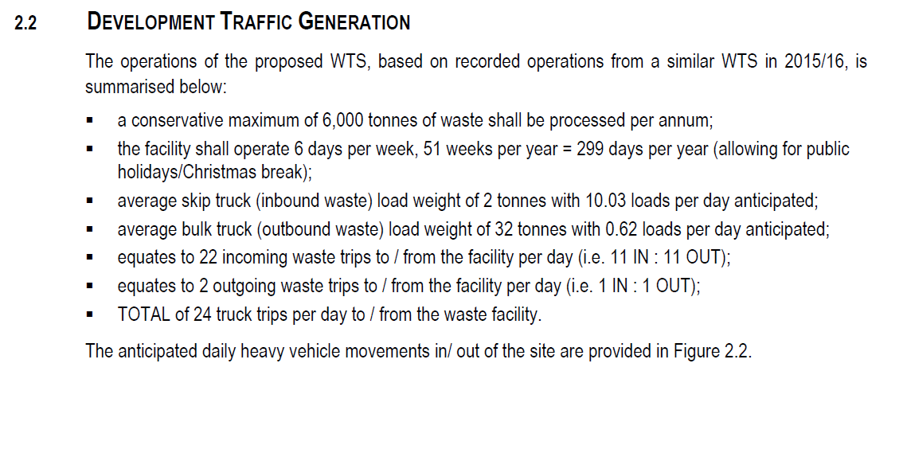

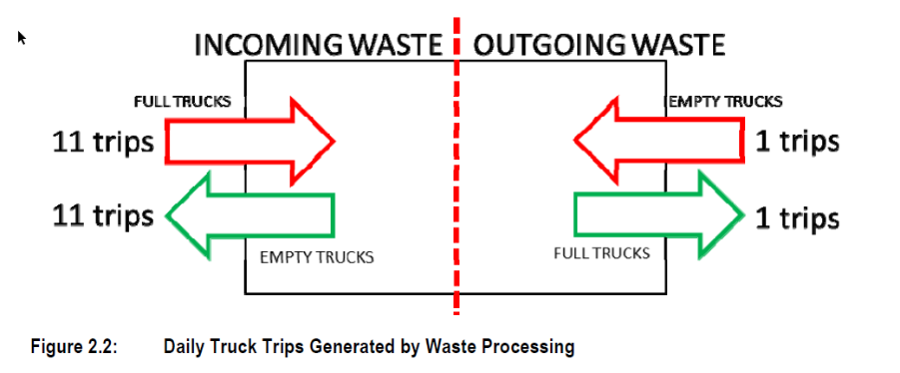

Using the same philosophy as previously advised by the proponent and based on the increased tonnages, the revised trip end calculation follows:

15000 tonnes of waste processed per annum:

Average skip truck inbound waste weight of 2 tonnes = (15000t/2) 7500 skip trucks in/ 7500 skip trucks out = 15000 trips

15000/365 =**41.1** daily trips

Average bulk truck outbound waste load of 34.5 t *(as per Bitzios report Feb 23 which advises 34-35 tonne)*

15000t/ 34.5t = 434.8 empty trucks in and 434.8 full trucks out

869.56/365 days

**2.38** daily trips

Total Waste Facility daily truck trips for 15 000t waste processing:

41.1 + 2.38 = **43.48**

The Feb 2023 Bitzios report in tabling the truck trips only counts the trips in one direction when the calculation needs to be in both directions namely to and from the facility as per their Feb 2017 assessment. This focuses on the peak hour movements for assessment of the road and intersection capacity constraints.

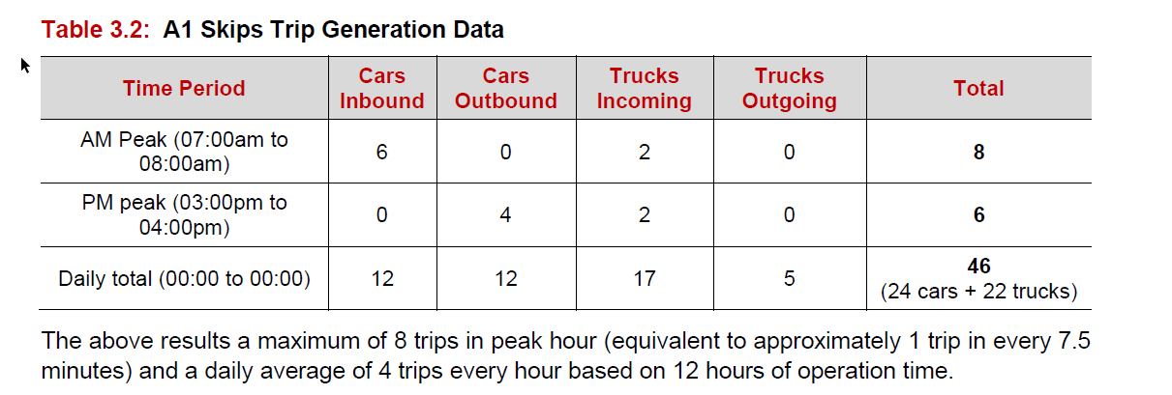

43.48 – 24 = **19.48** trips applicable.

The employment generating discount of 40% would apply to the dollar value of these trips (endorsed by the Director of Planning and Regulation).

1. **Section 4.15(1)(a)(iiia) – Planning agreements under Section 7.4 of the EP&A Act**

There have been no planning agreements entered into and there are no draft planning agreements being proposed for the site.

1. **Section 4.15(1)(a)(iv) - Provisions of Regulations**

Section 62 (consideration of fire safety) and Section 64 (consent authority may require upgrade of buildings) of the 2021 EP&A Regulation are not relevant to the proposal.

These provisions of the 2021 EP&A Regulation have been considered and are addressed in the recommended draft conditions (where necessary).

* 1. **Section 4.15(1)(b) - Likely Impacts of Development**

The likely impacts of that development, including environmental impacts on both the natural and built environments, and social and economic impacts in the locality must be considered. In this regard, potential impacts related to the proposal have been considered in response to SEPPs, LEP and DCP controls outlined above and the Key Issues section below.

The consideration of impacts on the natural and built environments includes the following:

* Context and setting – The proposed development is considered to be acceptable, having regard to the established context of the locality and the planned future character of the area. The proposal allows for the expansion of an operating approved land use. All impacts of the proposed development are discussed within this report. Impacts of the expansion are suitably addressed through recommended conditions of consent and appropriate management of the WRTS.
* Access and traffic – A Traffic Impact Assessment Report accompanies the Development Application as prepared by Bitzios Consulting. The report findings conclude a total of 22 heavy vehicle trips (2 trips per hour) a day based on actual traffic data. This calculation is lower than the 24 trips estimated under Development Consent No. DA16/0647 (as amended) which were based on assumptions. Council’s Traffic Engineer concurs with the findings of the report and raises no objections to the proposal, satisfied with the current arrangements in place. Based on the findings of the report Council’s Traffic Engineer is satisfied that the existing road network is sufficient with no road upgrades required.
* Natural hazards – flooding has been considered by Council’s Roads and Stormwater Engineer. No objections were raised by Council’s Engineer with respect to flooding. Council is satisfied that flood consisderations were suitably addressed under Development Consent No. DA16/0647 (as amended).

Accordingly, it is considered that the proposal will not result in any significant adverse impacts in the locality as outlined above.

* 1. **Section 4.15(1)(c) - Suitability of the site**

The WRTS was approved under Development Consent No. DA16/0647 (as amended). The upgrades proposed are considered to remain compatible with the surrounding land uses and development in the locality. Impacts on residential properties and the childcare centre to the north have been assessed and are determined to be acceptable given the mitigation measures already in place or recommended as conditions of consent in this report. The subject site is considered able to suitably accommodate the upgraded WRTS.

* 1. **Section 4.15(1)(d) - Public Submissions**

These submissions are considered in Section 5 of this report.

* 1. **Section 4.15(1)(e) - Public interest**

The proposed development is generally consistent with relevant environmental planning instruments and Council policy requirements. The proposal is considered suitable for the subject site given the existing approved WRTS (Development Consent No. DA16/0647 (as amended)) and industrial zoning. The proposed development will allow for the expansion of the WRTS and facilitate expanded recycling of construction and demolition wastes making a positive contribution to NSW Waste and Sustainable Materials Strategy 2041 targets. It is considered that any potential impacts from the development can be mitigated, subject to conditions of consent. The proposal is therefore considered to be in the public interest.

1. **REFERRALS AND SUBMISSIONS** 
   1. **Agency Referrals and Concurrence**

The development application has been referred to various agencies for comment/concurrence/referral as required by the EP&A Act and outlined below in Table 5.

There are no outstanding issues arising from these concurrence and referral requirements subject to the imposition of the recommended conditions of consent being imposed.

**Table 5: Concurrence and Referrals to agencies**

|  |  |  |  |
| --- | --- | --- | --- |
| **Agency** | **Concurrence/**  **referral trigger** | **Comments**  **(Issue, resolution, conditions)** | **Resolved** |
| Concurrence Requirements (s4.13 of EP&A Act) | | | |
| Environment Agency Head (Environment, Energy & Science Group within DPIE) | S7.12(2) - *Biodiversity Conservation Act 2016* | N/A | N/A |
| Rail authority for the rail corridor | Section 2.98(3) - *State Environmental Planning Policy (Transport and Infrastructure) 2021* | N/A | N/A |
| Referral/Consultation Agencies | | | |
| RFS | S4.14 – EP&A Act  Development on bushfire prone land | N/A | N/A |
| Electricity supply authority | Section 2.48 – *State Environmental Planning Policy (Transport and Infrastructure) 2021*  Development near electrical infrastructure | Referred to Essential Energy under Section 2.48. Essential Energy comments have been conditioned. | Y |
| Rail authority | Section 2.97 – *State Environmental Planning Policy (Transport and Infrastructure) 2021*  Development land that is in or adjacent to a rail corridor. | N/A | N/A |
| Transport for NSW | Section 2.121 – *State Environmental Planning Policy (Transport and Infrastructure) 2021*  Development that is deemed to be traffic generating development in Schedule 3. | Referred to TfNSW who raised no objections to the proposed development with no conditions recommended. | Y |
| Design Review Panel | Cl 28(2)(a) – SEPP 65  Advice of the Design Review Panel (‘DRP’) | N/A | N/A |
| Integrated Development (S 4.46 of the EP&A Act) | | | |
| RFS | S100B - *Rural Fires Act 1997*  bush fire safety of subdivision of land that could lawfully be used for residential or rural residential purposes or development of land for special fire protection purposes | N/A | N/A |
| Natural Resources Access Regulator | S89-91 – *Water Management Act 2000*  water use approval, water management work approval or activity approval under Part 3 of Chapter 3 | N/A | N/A |
| EPA | Clauses 34(3) and 42(3), Schedule 1 of the Protection of the Environment and Operations Act 1997 | After three requests for further information the NSW EPA are satisfied with the proposed development providing General Terms of Approval on 4 September 2023. | Y |

* 1. **Council Officer Referrals**

The development application has been referred to various Council officers for technical review as outlined **Table 6.**

**Table 6: Consideration of Council Referrals**

|  |  |  |
| --- | --- | --- |
| **Officer** | **Comments** | **Resolved** |
| Roads and Stormwater Engineer | Council’s Roads and Stormwater Engineer reviewed the proposal and raised no concern and recommended no conditions of consent. | Y |
| Traffic | Council’s Traffic Engineering Officer reviewed the proposal and raised no concern and recommended no conditions of consent. | Y |
| Building | Council’s Senior Building Surveyor reviewed the proposal and raised no concern subject to recommended conditions of consent. | Y |
| Environmental Health | Council’s Environmental Health Officer reviewed the proposal and raised no concern subject to recommended conditions of consent. | Y |
| Sustainability & Environment | Council’s Ecologist reviewed the proposal and raised no concern and recommended no conditions of consent. | Y |
| Water & Wastewater | Council’s Water & Wastewater Engineer reviewed the proposal and raised no concern and recommended no conditions of consent. | Y |

Issues raised by Council officers are considered in the Key Issues section of this report.

* 1. **Community Consultation**

The proposal was notified in accordance with the Council’s *Community Participation Plan 2019 – 2024* from Wednesday 26 April 2023 until Wednesday 24 May 2023. The notification included the following:

* An advertisement in the local newspaper Tweed Link;
* A sign placed on the site; and
* Notification letters sent to adjoining and adjacent properties;

The Council received a total of 1 unique submissions, comprising 1 submission in favour of the proposal. A copy of this submission is provided below:

*“As a practicing consultant town planner with more than 40 years experience I must voice my concern with how this application has been dealt with. Instead of advising the applicant that they could lodged a s.4.55 modification application- considered the most appropriate approvals pathway given the fact that an EIS based DA has already been approved for the site. Instead, Council town planning has put the proponent through the needless task of having to prepare yet another EIS, resulting in unnecessary costs and significant delays. I have no cavill with the proposed development. It is modest in scale being marginally larger than that approved in the original DA.”*

The above submission does not require a response.

1. **KEY ISSUES**

The following key issues are relevant to the assessment of this application having considered the relevant planning controls and the proposal in detail:

* 1. **Noise**

Whilst the subject site and adjoining sites are zoned E4 General Industrial, residential properties are located approximately 250m from the subject site raising particular concern with respect to noise emitted from the WRTS. Whilst noise impacts of the WRTS were assessed under Development Consent No. DA16/0647, the throughput of waste is increasing significantly in addition to a proposed change to the WRTS hours of operation resulting in further potential noise impacts for surrounding properties.

In response, the Applicant has provided an Environmental Noise Impact Report as prepared by CRG Acoustics Pty Ltd dated 13 February 2023 (crgref: 15184 report rev.6) and an Addendum Letter prepared by CRG Acoustic Pty Ltd dated 18 May 2023 (CRGref: 15184 Addendum Letter 18_05_23) on lodgement. This Report and the Addendum recommends the following noise mitigation measures:

*“Based upon the proposed increase in operational capacity, and earlier truck movements prior to 7am, the following acoustic treatments and management principles are recommended to mitigate onsite noise emissions:*

* + - *The 16 tonne trucks can enter and / or leave the site from 6:30am provided the following management controls are incorporated:* 
      * *The impact between the skip chain and the truck / skip is to be mitigated by the use of a damping material such as a heavy vinyl or rubber (i.e. conveyor rubber).*
    - *Larger 24 tonne truck movements and all other onsite operational activities and equipment associated with the waste recycling (i.e. loader, excavator, sorting equipment and activities) are to remain limited to the hours between 7am to 6pm Monday to Saturday.*
    - *Onsite drivers (i.e. loader, trucks and excavator) be instructed to operate equipment in a manner that does not generate unnecessary noise, through avoiding excessive revving of motors, and avoidance of impact with solid objects.*
    - *No alarm bells or paging systems should be used. Cordless telephones are a suitable substitute. • Vehicles have a modified beeper installed (commonly termed a “croaker”, as they sound similar to a frog croak).*
    - *Onsite machinery and trucks are to be fitted with exhaust controls that minimise noise pollution in accordance with current legislation and industry best practices.*
    - *All engines including trucks are to be maintained and tuned to manufacturer’s specifications so as to minimise exhaust emissions.*
    - *Equipment speeds be limited to 20km/hr on the site.*
    - *Provide neighbours with a contact number should any problem arise. In the event of a noise complaint, the complaint must be dealt with sensitively and respectfully, with the noise abated as soon as possible. A complaint register must also be completed and stored (refer to Appendix C for an example of a complaint register).*
    - *Update and maintain a noise management plan (NMP) prepared by a suitable qualified and experienced noise consultant”*

Additionally, as per the requirements of Development Consent No. DA16/0647 (as amended) an acoustic barrier is located around the western and northern perimeters that is a minimum of 3.5m high above the grade level of the hardstand areas mitigating noise from the WRTS. In addition, a 2.5m high lapped timber paling acoustic fence is located along the southern boundary fronting Naru Street and the site. All other previous acoustic treatments and management control recommendations which formed part of Development Consent No. DA16/0647 are to remain in place.

Council’s Environmental Health Officer concurs with the findings and recommendations of the Noise Impact Report and has no concerns with respect to noise, subject to recommended conditions of consent. Of note, Council has conditioned that a maximum of two (2) movements for trucks up to 16 tonnes only are permitted between the hours of 6:30am and 7:00am as recommended by CRG Acoustics.

The NSW EPA have included conditions limiting noise in their general terms of approval as per below:

***L5.1*** *Noise generated at the premises must not exceed the noise limits at the times and locations in the table below.*

|  |  |  |  |
| --- | --- | --- | --- |
| Location | Noise Limits in dB(A) | | |
| Morning Shoulder | | Day |
| LAeq(15 minute) | LAmax | LAeq(15 minute) |
| 16 Anne Lane, Chinderah (Lot 105, DP 755701) | 37 | 65 | 49 |
| 25-33 Anne Lane, Chinderah (Lot 3, DP 1110494) | 35 | 56 | 44 |
| 109 Naru Street, Chinderah (Lot 115, DP 56789) | 35 | 43 | 42 |
| 30 Naru Street, Chinderah (Lot 5, DP 1185359) | 40 LAeq(15 minute) when in use | | |

Resolution: The issue has been resolved through recommended conditions of consent as outlined in **Attachment A**.

* 1. **Odour**

An Air Quality and Odour Impact Assessment was prepared to accompany the EIS. This report concluded that “There is negligible potential for odour emissions because the site does not receive odorous wastes”.

Council’s Environmental Officer has provided the following with respect to air pollution/emission of odours from the WRTS.

*“The operation does not receive any odorous or hazardous waste on site. Garden organics are from demolition and construction sites only and material is generally woody and contains no odour. The garden organics received will be sorted inside the shed.”*

Council and the NSW EPA are satisfied that no odour impacts will occur as a result of the upgrades to the WRTS.

Resolution: The issue has been resolved through recommended conditions of consent as outlined in **Attachment A**.

* 1. **Amenity**

The M1 Pacific Highway is noted to the south, with industrial land including a sand quarry to the west, industrial development to the east, and Naru Street and residential and commercial development including two caravan parks and a childcare facility to the north/northeast. No submissions have been received in relation to the operation or amenity impacts from the proposal. Council’s Environmental Health Officer has reviewed the proposal with respect to amenity and is satisfied that amenity impacts are suitably managed and mitigated. Further to this, the NSW EPA will regulate the site to ensure compliance.

Resolution: The issue has been resolved through recommended conditions of consent as outlined in **Attachment A**.

* 1. **Waste (including contaminated waste)**

Council’s Environmental Health Officer has assessed waste impacts from the proposed development. Their summary is provided below:

*“Waste will be transported to the facility in skip bins from A1 Skips owned and operated vehicles and will be unloaded, sorted, and processed. Any recyclable materials will be sold for reuse and any non-recyclables will be transported to landfill for disposal. All waste sorting and processing at the site will occur wholly within the warehouse. A removable weighbridge is installed outside the sorting shed. The outdoor hardstand is used for traffic movement, weighbridge construction, vehicle parking and open storage space for timber and concrete wastes.*

*Timber and construction waste storage areas are located at the south-east corner of the property. The waste sorting areas are located within the warehouse with a weighbridge installed just outside the entrance of the sorting area. All sorting works are proposed to be carried out within the warehouse storage of incoming materials will be in the open storage areas located outside and at the southern end of the property.*

*A Waste Management Plan for Waste Transfer Station Upgrade, 16 Naru Street, Chinderah prepared by Jackson Environment and Planning Pty Ltd dated 24 November 2022.*

* *The plan addresses the operational phase only. No demolition or construction proposed.*
* *All waste sorting and processing at the site will occur wholly within the warehouse.*
* *Proposed works include covering outdoor concrete and timber storage areas when not in use to minimise wind erosion of material stockpiles and washing of stockpiles during a rainfall event.*
* *Inspected waste materials will be separated and stored in separate, designated storage bays for each waste material will be accepted. Sorted and recovered products will be collected and transported as required for off-site recycling.*
* *The facility accepts garden organics and construction and demolition wastes including garden organics skips, concrete skips, and mixed rubbish bins. It does not accept special wastes (including asbestos), liquid waste, hazardous waste, restricted solid waste or general solid waste (putrescible) including soil, rocks, plastics, metal, food, chemicals, paint, tyres, and batteries.*
* *Waste materials to landfill will be delivered approximately twice a day – once in the in afternoon and once before close of business. This best practice management system reduces the risk of dust and maintains good air quality inside the shed, keeping the site clean and refreshed.*
* *Scheduled activity – Waste Processing (non-thermal treatment) – and will require an Environment Protection Licence issued by NSW Environment Protection Authority (EPA).*
* *Protection of the Environment Operations (Waste) Regulation 2014 – Clause 90C, scheduled waste facilities that are defined as a ‘construction and demolition waste facility’ shall comply with the requirements of the NSW EPA’s Standards for Managing Construction Waste in NSW.*
* *A procedure to achieve compliance with NSW EPA Construction and Demolition Waste Standards has been included in the Plan.*

*The material stored on site are not classified as hazardous wastes and is exempt from the considerations of Chapter 3 of SEPP (Resilience and Hazards) 2021.*

*Regarding the Standards for Managing Construction Waste in NSW, the applicant notes that compliance with the Standards is a compulsory licence condition for all construction and demolition waste facilities. Failure to comply with the Standards is a breach of Section 64 of the Protection of the Environment Operations Act 1997. The site’s Operational Environmental Management Plan (OEMP) will need updating to demonstrate compliance with these requirements. Conditions to apply.*

Additionally, the NSW EPA have conditioned ongoing operations and waste management to ensure compliance within their supplied general terms of approval.

Resolution: The issue has been resolved through recommended conditions of consent as outlined in **Attachment A**.

* 1. **Leachate**

Whilst Council was satisfied with the arrangement, the NSW EPA as the licensee for this application raised particular concern over ‘leachate’ management during their assessment of the application. An acceptable resolution was reached between the Applicant and the EPA to require a grated trench drain be provided along the front of the concrete and timber storage bays. This drain will receive any ‘leachate’ created within the storage bays, where it will then be directed to a below-ground impervious concrete sump with a minimum volume of not less than 500 litres. Any captured ‘leachate’ will then be transferred to a lawful facility for disposal. This ensures that no leachate from the timber and concrete storage bays can enter the stormwater system.

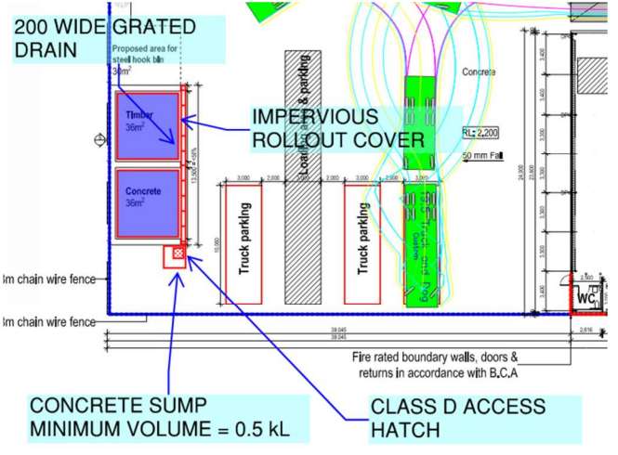

*Figure 7. Leachate Management System (Eclipse Consulting Engineers, 29 June 2023)*

Resolution: The issue has been resolved through recommended conditions of consent as outlined in **Attachment A**.

1. **CONCLUSION**

This development application has been considered in accordance with the requirements of the EP&A Act and the Regulations as outlined in this report. Following a thorough assessment of the relevant planning controls, issues raised in submissions and the key issues identified in this report, it is considered that the application can be supported.

The proposed upgrade works are considered suitable for the site as it is a permissible form of development and is compatible with the existing WRTS. All relevant planning considerations have been taken into account in the assessment of the application. It is considered that the proposal would to facilitate the recycling of construction and demolition waste in the Shire and greater Northern Rivers/Gold Coast region, making a positive contribution to NSW Waste and Sustainable Materials Strategy 2041 targets and sustainable waste management in the Shire. As such, Council is satisfied that the proposed development is acceptable on merit and can be conditioned to adequately mitigate any impacts associated with the development.

It is considered that the key issues as outlined in Section 6 have been resolved satisfactorily through amendments to the proposal and/or in the recommended draft conditions at **Attachment A**.

1. **RECOMMENDATION**

That the Development Application [DA No 23/0113] for a waste transfer station upgrade at Lot 1 DP 1185359; No. 16 Naru Street CHINDERAH be APPROVED pursuant to Section 4.16(1)(a) of the *Environmental Planning and Assessment Act 1979* subject to the draft conditions of consent attached to this report at Attachment A.

The following attachments are provided:

* Attachment A: Draft Conditions of consent